

NETWORKING

INTERNATIONAL SCHOOL OF MANAGEMENT AND TECHNOLOGY



Bisesh Shrestha(HND/ First Semester)

Contents

Part1 7

INTRODUCTION 7

Benefits and constraints of different networking types and standards 7

1. Peer to peer 7

➢ Benefits 7

➢ Constraints 7

2. Client server 8

➢ Benefits 8

➢ Constraints 8

3. Cloud 8

➢ Benefits 8

➢ Constraints 8

4. Cluster 8

➢ Benefits 9

➢ Constraints 9

Centralization 9

➢ Benefits 9

➢ Constraints 9

Virtualization 9

➢ Benefits 9

➢ Constraints 9

OSI model 10

➢ Benefits 10

➢ Constraints 10

TCP/IP model 10

➢ Benefits 11

➢ Constraints 11

Network standard 11

Impact of network topology, communication and bandwidth requirement 11

1.Bus topology 12

2.Ring topology 12

5. Star topology 13

6. Mesh topology 14

7. Tree topology 14

8. Hybrid topology 15

Selection of network topology for the network system 16

Networking devices 16

Operating principle of networking devices & server types 16

1. Repeater: 16

2. Hub 17

3. Bridge 17

4. Switch 18

5. Router 18

6. Server 18

7. Firewall 19

8. Wireless networking devices 19

9. Access point 20

Interdependence of workstation hardware 20

Comparison of OSI model & TCP/IP model 21

Protocols 22

Series/model of same brand 24

Conclusion 24

Part 2 24

Introduction 25

Network design of lanmark IP 25

Server used on network design: 26

Devices used 27

Testing of design(testing only server) 28

1.test of ADDS 28

2. test of DHCP 28

3. test of VPN server 28

4. test of PRINT server 28

5. test of WEB server 28

Project title: network design & implementation of landmark it pvt.ltd. 29

User feedback 29

Conclusion 29

LAB REPORT 30

DOMAIN CONTROLLER(ADDS) 30

Domain Name System(DNS Server) 41

Internet information Services(IIS) Server 53

DHCP installation: 57

RODC Server: 64

CDC server: 68

Print Server 70

VPN 76

Maintenance schedule 85

Analyses of expected 85

1. ADDS 85

2. DHCP 85

3. VPN server 86

4. PRINT server 86

5. WEB server 86

➢ Recommendation for potential 86

Summarization of all the task 87

Bibliography 88

**Report on networking and its surrounding components**

**Prepared by**

Bisesh Shrestha

Section: J

2019 July, 04

Table of content

INTRODUCTION

Benefits and constraints of different networking types and standards

1. Peer to peer

➢ Benefits

➢ Constraints

2. Client server

➢ Benefits

➢ Constraints

Network standard

Impact of network topology, communication and bandwidth requirement

1.Bus topology

2.Ring topology

3. Star topology

4. Mesh topology

5. Tree topology

6. Hybrid topology

Selection of network topology for the network system

Operating principle of networking devices & server types

Types of server

Interdependence of workstation hardware

Comparison of OSI model & TCP/IP model

Protocols

Series/model of same brand

Conclusion

# Part1

LO1 Examine networking principles and their protocols.

LO2 Explain networking devices and operations.

# INTRODUCTION

Interconnection of two or more computers for sharing resources (hardware and software) among them is called computer network. The physical arrangement managements of network are topology. Some many devices, software & operating systems are used on computer network. They all have their own specific task & operating principles. All they have to work together to perform a complete task. Although there are so many network types & standards, all they have to follow some network models like OSI & TCP/IP.

# Benefits and constraints of different networking types and standards

## Peer to peer

It is very simple types of network mainly used by small organization like school co-operatives etc. only for shearing of resources. This type of network do not use server so all computer acts as an server &client itself so all they are equally powered.

### Benefits

Due to very simple type of network, it is very cheaper easy to setup, manage & maintain because it does not use any server. It does not need highly qualified IT professional. It cannot be trouble shoot very easily

### Constraints

Due to lack of server this type of network has no security /lack of security, so it is not suitable for large scale organization & also it has lack of centralize control, manage ,& monitor. Data backups is difficult, each & every computer should be monitored individually

## Client server

A computer network in which have one centralized computer called server, which control and manage security and network of client computers, which are connected in server. Client access programs and data stored on server.

### Benefits

In this networking, system files are stored on a server. Client can access and share data from that server so security is strong. Capacity of client and server can be increased separately.

### Constraints

This server is expensive to purchase because it requires special server with large memory .In this networking system, if any part fails then a lot of errors may occurs so network specialist are needed to configure or implement it.

## Cloud

A cloud is an unpredictable part of a network through which one or more network resources are searched or implemented. This requires the exchange of some or all of the network operations to the cloud computing network. (Networkskyx.com, 2019)

### Benefits

The most significant advantage is reducing IT costs. It is much more reliable and consistent on the service management platform. It provides maintenance capabilities through centralized administration of resources.

### Constraints

There are many times when this system can have some sincere malfunction at a time when data can be picked up anywhere at any time. It can transfer confidential company information to third party (a cloud service provider).

## Cluster

A server group that behaves as one system and has a high enable ability that is connected through a LAN is called a cluster. This is the logical unit for storing files and data on the hard disk, which is organized by the operating system of the computer (operating system).

### Benefits

This reduced the single point of failure due to the functionality of switching the virtual Exchange server. With limited downtime, it has a high ability to perform maintenance and upgrades.

### Constraints

It shares storage errors. It also does not serve network services. It shows the error in working order. Otherwise, an unnecessary geographically distributed solution for clustering was implemented as a result of disaster sites.

## Centralization

This is the type of computational architecture on the central server on which all or most of the calculations are performed, which is the acting agent for all communications.

### Benefits

This helps reduce costs, because more equipment and machines are not supported. Improved data security. It consists of processing in centralized processing systems.

### Constraints

The data are independent of each other for other information systems. Huge data storage is necessary in the central information system, which will help to reduce local accountability. Transactions are very expensive to transfer.

## Virtualization

It describes the formation of a virtual resource, such as a computer / desktop, operating system (OS), server, network or file. This is a storage device or network resources. Its main goal is to make it more scalable by managing workloads by converting traditional computing.

### Benefits

This makes the reformation very fast and accurate, with limited frames and equipment share - all this is virtually. He performed more efficient IT operations.

### Constraints

Since it does not require the installation of hardware components, it is a cheaper system for implementation. This reduces the load. This allows you to quickly deploy resources. It offers the best uptime.

## OSI model

This is a related model for how the application connects over the network through systems that are open to connect and communicate with other systems. This is the conceptual basis for understanding relationships, therefore it is divided into seven components or layers, each of which has different types of services that should be provided to the layers above and below. Layers and components:

1. Physical layer
2. Data link layer
3. Network layer
4. Transport layer
5. Session layer
6. Presentation layer
7. Application layer

### Benefits

It is considered a standard model in computer networks. It provides a wide range selection. It does not lie on a particular computer system that must be executed. For security reasons, the data is encrypted. In this OSI model, just add a few network models.

### Constraints

Data integrity is not required in many applications that are supported by the OSI model. OSI needs to be understood between the three parties that are users and the service provider, for quicker setup. It is difficult to understand, because it is a complex model.

## TCP/IP model

This means the transmission control protocol / internet protocol. This is the language in which Computer \ PC users come to the Internet, which can be worn as a communication protocol on a private network. It works under four layers. They are:

1. Application layer
2. Transport layer
3. Internet layer
4. Network Access layer

### Benefits

This means the transmission control protocol / internet protocol. This is the language in whichComputer \ PC users come to the Internet, which can be worn as a communication protocol on aprivate network. It works under four layers.

### Constraints

It is difficult to organize and maintain. IPX is much faster than the TCP / IP model. Small TCP /IP is higher than IPX

## Network standard

Networking standards identify the data communication laws required for networking technologies and procedures to be interoperable. Standards help to create and maintain open markets and enable different vendors to compete with existing market products on the basis of the quality of their products.

In today's networking there are many different standards used

|  |  |
| --- | --- |
| **Layer** | **Common Standards** |
| 5. Application layer | HTTP, HTML (Web) MPEG, H.323 (audio/video) SMTP, IMAP, POP (e-mail) |
| 4. Transport layer | TCP (Internet and LANs) SPX (Novell LANs) |
| 3. Network layer | IP (Internet and LANs) IPX (Novell LANs) |
| 2. Data link layer | Ethernet (LAN) Frame relay (WAN) T1 (MAN and WAN) |
| 1. Physical layer | RS-232C cable (LAN) Category 5 cable (LAN) V.92 (56 Kbps modem) |

Types of network standard

1. **De-facto:** These are the standards which every organization follows without any official strategy or authorization. They came into being because of traditions or facts.
2. **De jure:** Most of today's communication standards are de jure standards. These standards are those passed by any formally acknowledged standards organization through laws.

# Impact of network topology, communication and bandwidth requirement

### 1.Bus topology

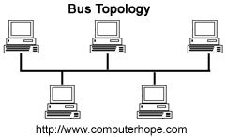Bus topology are those type of network topology in which all the devices such as computer, workstation, printer, servers etc are connected through single cable.

* Advantages of bus topology

It is easy to connect computers because computers are connected through single cable.

* Disadvantages of bus topology

Due to connection of devices in single cable, all the network will be shut down if there is any problem in that main cable

* Impacts

Its impact on communication is worst as if cable fails then interaction will not occur. in term of bandwidth if there is high traffic then collisions will be maximized. For this it is mandatory to use protocols such as Aloha, Pure Aloha, etc.

### 2.Ring topology

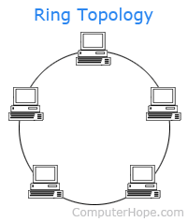Ring topology are those type of network topology which is used in LAN (local area network) or WAN (wide area network) in which devices such as computers, workstation, printer etc are connected to two other point creating circular path such as circle.

* Advantages of ring topology

In this topology, Devices are connected in circular path so data flows in one direction either clockwise or anti-clock wise so, there will be less chances of data collisions. Server is not needed to connect computer so it is easy to setup and data transfer rate is higher between computers.

* Disadvantages of ring topology

Hardware used in connection of each computer are expensive and is slower than other topology because data are transferred through all the computers. If any computer fails in network then entire network will be impact because data cannot be transferred in their destination

* Impacts

It does not have negative impact on communication. Reason behind this is that, in this repeaters are used so that if 50 node sends data to 1stnode then it has to go through 49 nodes, so to prevent it and have effective communications they are being sued. In terms of bandwidth it’s high and can range to large distances

### Star topologyStar topology

Star topology are those type of network topology which is one of the most common used topology. In this topology, computers are connected to network devices such as hub, switch which act as a server.

* Advantages of star topology

All computers are connected to network devices such as hub, switch. There will not be any network failure, if one computer on network fails. Computers can be easily added in this topology.

* Disadvantages of star topology

This topology is expensive to configure because network devices such as hub, switch are used in this topology. If network devices goes down then all computers will be disconnected.

* Impacts

It can have negative impact on communication as if hub fails then entire network will be stopped. Its bandwidth is dependent on performance of hub and its capacity to connect to different devices. There is inefficient use of bandwidth, consider an example like if there is an hub with 8 ports and five devices are connected with it, then it is ensured that data is sent to right port but rest 3 ports are not used.

### Mesh topology

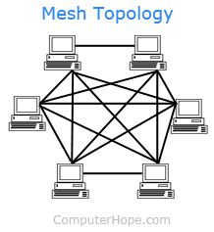Mesh topology are those type of network topology, which is commonly use in wireless networks. In mesh topology, all computers are interconnected with each other.

* Advantages of mesh topology

Due to interconnection of computers, data can be transfer easily between two computers, which provides security and privacy also. There will not be network failure if one computer goes down

* Disadvantage of mesh topology

Installation and configuration are difficult because all computer are interconnected. It is difficult to find out where the errors are occurred because cabling are hard to handle.

* Impacts

It is a point to point connection with other devices or nodes. in this all nodes are linked with each other, in this communication which occurs is effective as each system is connected directly with each other, in this case bandwidth is improvised with respect to ring topology as devices have dedicated link with each other

### Tree topology

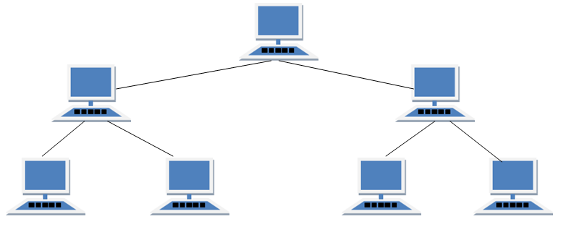Tree topology is those type of topology in which devices are connected or arranged like branches of tree. This topology is also called hierarchical topology because of it hierarchy form. This topology is used in WAN (wide area network).

* Advantages of tree topology

It is easier in maintenance and faultfinding. Scalable as leaf nodes in the hierarchical chain can contain more nodes. If one of them gets harmed, other hierarchical networks will not be impacted.

* Disadvantages of tree topology

Much maintenance is required because huge cabling is required.

* Impacts

The most significant weakness of tree topology is the root node. If the root node fails then all of its sub trees become partitioned. There will still be partial connectivity within the network amongst other devices such as the failed nodes parent.Maintaining the network system is not simple either because the more nodes you add, the more difficult it becomes to manage the network. Another disadvantage of a tree topology is the number of cables you need. Cables are required to connect every device throughout the hierarchy which makes the network layout more complex when compared to a simpler topology.

### Hybrid topology

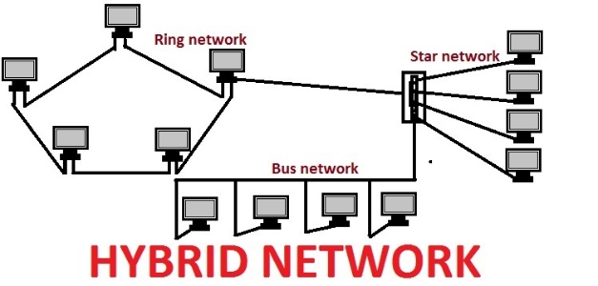Hybrid topology is those type of network topology in which two or more than two topologies such as Ring topology, bus topology, star topology, mesh topology, ring topology and tree topology are connected.

* Advantages of hybrid topology

Due to interconnection of topologies, functions of both topology are combined thus it increase data transfer rate and weakness of a topology is decreased.

* Disadvantages of hybrid topology

Due to connection of two or more topology, managing network is harder or it became challenging. For installation and configuration of this topology, skilled person is needed. This type of network topology is used in large scale so it requires large amount of cabling, advance network devices, which make Cost installation expensive.

* Impacts

Unfortunately, hybrid topologies can be quite complex, depending on the topologies that you decide to use. Each topology that is part of your hybrid topology will have to be managed according to its unique network requirements. This makes administrators jobs more difficult because they are going to have to attempt to manage multiple topologies rather than a single one. In addition, setting up a hybrid topology can end up being quite costly.

# Selection of network topology for the network system

Although there are so many network topologies, we have selected star topology for our networking system because it is also one of the most frequently used computer network topologies and provide more privacy compared to other network topologies. Each device is connected to the hub by a link. This makes it easy to isolate the individual equipment. This isolation nature also protects the network from affecting any non-centralized error.

It is possible to have all the important data backups on the hub in a private folder in a Star Network Topology and so if the computer fails you can still use your data using the next computer in the network and access the backup files on the hub. It is simple to monitor and manage the network because of the centralization in star topology, making it more advantageous.

## Networking devices

A computer network is a collection of collective network devices that are well organized to share data. Network devices are devices necessary for network management, network binding, packet routing. Communicate with others, share files on the network and much more. The various network devices and server types are described below:

## C:\Users\Bises\AppData\Local\Microsoft\Windows\INetCache\Content.MSO\42D31E67.tmpOperating principle of networking devices & server types

1. Repeater: The job of a repeater is to regenerate the signal over the same network before the signal becomes too weak or corrupted to extend the length to which the signal can be transmitted over the same network. An important point for repeaters to note is that they do not amplify the signal. They duplicate the signal bit by bit and regenerate it at the initial force when the signal becomes soft.
2. 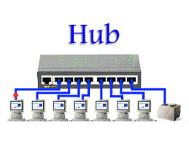Hub: A hub is essentially a multiport repeater. A hub links various cables from various branches. For example, a star topology connector that links various stations. Hubs can not filter data, so all linked systems will receive data packets. They also have no intelligence in finding the easiest route for data packets, leading to inefficiencies and waste. There are two types of hub.
   1. **Active Hub**: These are the hubs that have their own power supply and are able to clean, increase and relay the network signal. It acts as both a repeater and a cable center. These are used to stretch the highest node range.
   2. **Passive Hub**: These are the hubs that capture node wiring and active hub power supply. These hubs relay signals to the network without cleaning them up and boosting them, and cannot be used to extend node range.
3. 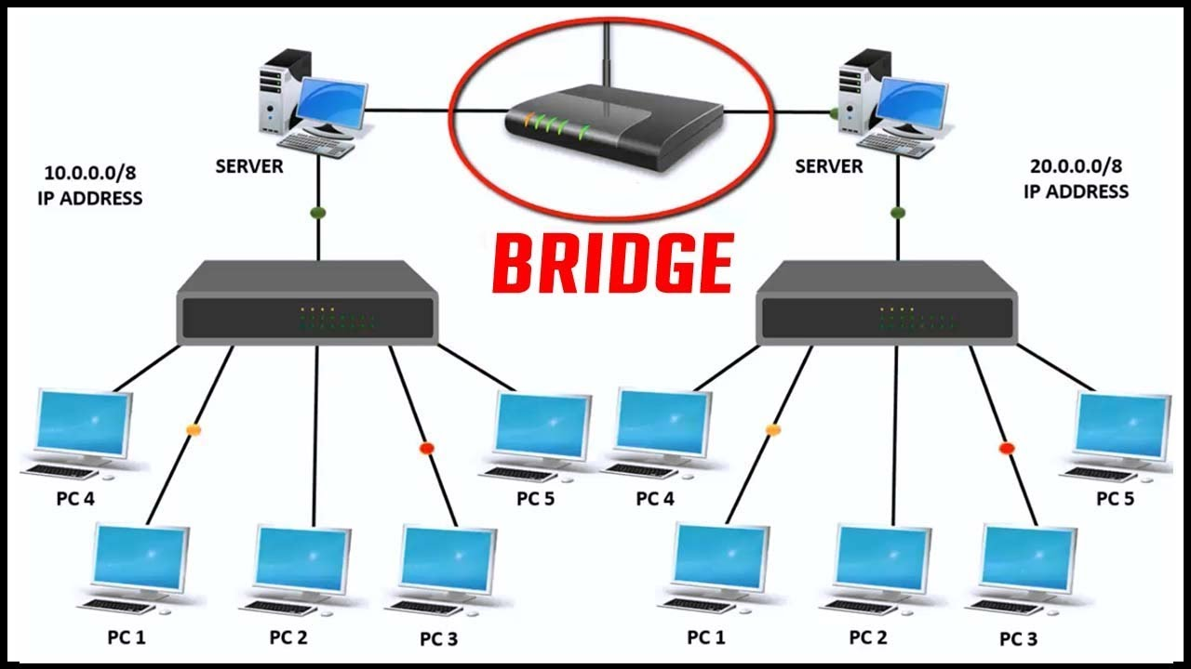Bridge**:** A bridge works on the layer of the data connection. A bridge is a repeater, adding content filtering features by viewing the origin and target MAC addresses. It is also used to connect two LANs that operate on the same protocol. It has one input and one output port, making it a 2 port unit. There are 2 types of bridge they are
   1. **Transparent bridge:** These are the bridge where the stations do not know the presence of the bridge.ie whether a bridge is built or removed from the network.
   2. **Source routing bridge:** Routing procedure is conducted by source station in these bridges and the frame defines the path to be followed.
4. 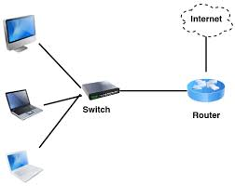Switch**:** A switch is a multi-port bridge with a buffer and a design that can boost its efficiency and performance (a large number of ports implies less traffic). Switch is the tool for the data link layer. Before transmitting information, Switch can conduct error checks, which makes it very effective as it does not transmit packets that have mistakes and selectively transmit useful packets to proper port only.

Multi-Layer Switch: A network device that can implement the functions of a switch, as well as a router without standing speed that can perform at higher levels of the OSI reference model, is called multilevel switch. Multilevel switches use hardware ASICs to perform routing properties. It works in two efforts between the Routing Processor (RP) and the Switching Mechanism (SE), Because RP receives the packets where the routing is performed and the packet is forwarded to the desired destination.

1. 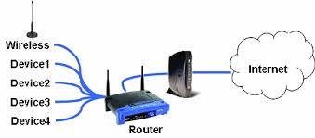Router**:** A router is a tool like a switch that uses their IP addresses to route data packets. Router is primarily a tool for the Network Layer. Routers usually attach LANs and WANs together and have a routing table that is dynamically updated to create decisions about routing data packets. Router divides broadcast areas from linked hosts.
2. Server**:** This is a computer program that serves the program for another computer program and its user. It provides data systems on a local area network (LAN) or a wide area network (WAN) filled with the Internet. For example: a web server, a mail server, a file server, etc. A simple server property is to visit the port for incoming network requests and a good presentation. Different types of servers contain their own functions.

#### Types of server

* **File server:** It Store and distribute documents from file servers. You can exchange units placed on a server with multiple customers or clients. Furthermore, centrally storing records provides easier alternatives for backup or fault tolerance than trying to provide file safety and integrity on any computer in an organization.
* **Print server:** Print servers enable printing features to be managed and distributed. Instead of attaching a printer to each workstation, a single print server can connect to countless client demands for printing. Some bigger and higher-end printers now come with their own built-in print server, removing the need for an extra computer-based print server.
* **DNS server:** Domain Name System (DNS) servers are application servers that provide client computers with name resolution by converting names that are easily understood by humans into IP addresses readable by machines. The DNS system is a widely spread name and other DNS server database, each of which can be used to submit a machine name that is otherwise unknown. The DNS server responds from its naming table with the necessary IP address.
* **Mail server:** Mail servers are an application server of a very prevalent sort. Mail servers receive messages sent to a user and store them on behalf of that client until they are received by a user. Having an email server enables the proper configuration and connection of a single device to the network at all moments. It is then prepared to submit and obtain emails instead of forcing each client machine to continually run its own email subsystem.

1. 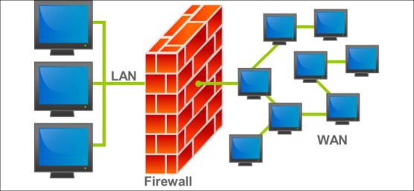Firewall: A network security system designed to secure a private network is called a firewall. It can be performed as hardware and software, and a combination of both. It blocks unauthorized access and is often formed to prohibit accessible Internet users from accessing private networks connected to the Internet. This prevents malicious attacks on our computers.
2. Wireless networking devices**:** Wireless networks are computer networks in which electromagnetic waves transmit a signal over communication channel that are not connected by cables of any type that are performed by wireless network devices.
3. Access point**:** An access point is a station on a local area network (LAN) that provides wireless devices and wired networks for linking transmitted and received data. It provides communication between the WLAN and the supported wired network and connects users to other users on the network. The principle of the AP s is for broadcasting a wireless signal that a computer can detect, with which it can communicate with the network without using any wires.

# Interdependence of workstation hardware

A workstation is a machine that is quicker and more capable of individual use than a personal computer. Because they are PCs, they can also be used separately of the mainframe if they have mounted their own apps and storage of their own hard disk. We will be discussing workstation hardware interdependence with relevant networking software.

1. **Server Operating System:**

A server operating system is an operating system specifically designed to run on servers that are specialized computers operating within client / server architecture to serve client computers requests on the network. The server operating system, or server operating system, is the software layer on top of which other software programs or applications can run on the hardware of the server. Server operating systems help in enabling and facilitating typical server roles such as web servers, mail servers, file servers, database servers, application servers and print servers.

It has ability to access the server in both the GUI at the same command level. Execute all or most OS-commanded procedures. Hardware, software and network settings facilities are advanced in server OS. It provides a main user interface, safety and other administrative procedures and Client machines and/or working systems are managed and monitored. Some popular server operating systems instances include: Red Hat Enterprise Linux, Windows Server, Mac OS X Server etc.

1. **Client operating System:**

The Client Operating System is the system that works with various portable devices and computer desktops. It is a distributed application framework that divides activities or workloads among resource or service suppliers, called servers. Clients and servers often interact on distinct hardware over a computer network, but both client and server may be on the same machine. A client shares none of its resources, but asks for the content or service function of a server. Client operating systems can be supported by smartphones and small computer devices.

Client-server computing utilizes the authority of the desktop system for local processing. It changes the ways in which companies access, distribute, and use information. With this strategy, information is no longer under the narrow command of senior managers and employees of MIS (Management of Information Systems), it is easily accessible to middle-ranking employees and personnel. They can actively participate on behalf of the business in the decision-making and procedure. The company becomes more versatile and responding more quickly to the evolving external business setting.

1. **Firewall**

A firewall is software that is used to keep a private network's safety. Firewalls block unlawful access to or from private networks and are often used to avoid unlawful web customers or unlawful software from accessing Internet-connected private networks. Using hardware, software or a combination of both, a firewall can be implemented. It uses different types of methods such as: packet filtering, application gateway, proxy server, etc.

# Comparison of OSI model & TCP/IP model

Comparing using Table:

|  |  |  |  |
| --- | --- | --- | --- |
|  | Comparison | TCP/IP model | OSI model |
| 1 | Meaning | It is a client server model that is used for internet data transmission. | It is a theoretical model used for the scheme of computing. |
| 2 | Layers | 4 layers | 7 layers |
| 3 | Expanded to | Transmission Control Protocol/ Internet Protocol | Open system Interconnect |
| 4 | Protocol | It's not simple to replace protocols. | Protocols are concealed in the OSI model and can readily be substituted with modifications in technology. |
| 5 | Delivery of packet | It does not guarantee packet distribution. | The transport layer ensures packet distribution. |
| 6 | Tangible | Yes i.e. touchable | No i.e. untouchable |
| 7 | Usage | Mostly used | Never used |
| 8 | Developed by | Department of Defense (DoD) | ISO (International Standard Organization) |

**Diagrammatic Comparison**

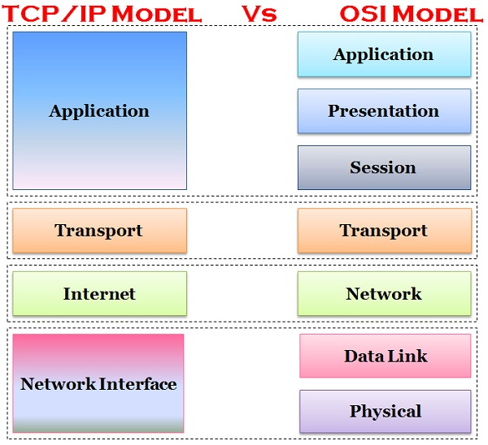

## Protocols

1. **TCP/IP (Transmission control protocol/internet protocol)**

Transmission Control Protocol / Internet Protocol is a set of communication protocols that are used to connect internet network devices. TCP / IP can also be used in a personal network (intranet or extranet) as a communications protocol. It indicates how information is transferred over the Internet by offering end-to-end protocols that define how packets should be broken, resolved, transferred, routed and obtained at the location. Which needs little central management and is designed to promote networks reliable, with the capacity to automatically recover from computer error on the network.

1. **HTTP &HTTPs(hypertext transfer protocol)**

HTTP (Hypertext Transfer Protocol) is a collection of guidelines for transmitting documents (text, graphics, noise, video, and other multimedia items) on the World Wide Web. It is a commonly used protocol, and due to its simplicity, it was quickly embraced over the Internet. Client-server model is used where the client is the web browser and communicates with the internet server hosting the website. The browser uses HTTP to connect to the server and to collect Web content for the user, which is performed over TCP / IP.

1. **POP( Post office protocol)**

Post Office Protocol (POP) is a type of conventional Internet and computer networking protocol that extracts and retrieves email from a separate mail server for host machine access. POP operates through an email client that supports POP to connect to the distant email server and download email messages to the recipient's computer device. POP uses the network connection TCP / IP protocol stack and operates with the Simple Mail Transfer Protocol (SMTP) for end-to-end email communication, where POP sends emails and SMTP sends them to the server.

1. **IMAP( internet message access protocol)**

IMAP is a normal protocol for accessing email from a local client on a distant server. It is an application layer Internet Protocol to create host-to-host communication facilities for applications using the fundamental transport layer protocols. This enables distant mail servers to be used. It also allows users to send and obtain messages via a remote server without any device support. Some of the advantages of IMAP include deleting messages, searching for keywords in the email body, creating and managing various mailboxes or folders, and viewing headings for simple visual email scanning.

1. **FTP( file transfer protocol)**

File Transfer Protocol (FTP) is a client / server protocol that is used to transfer data to a host computer or to exchange documents. User names and passwords can authenticate it, which enables users to access internet files, programs and other data without a use r ID or password. With standardized instructions and syntax, the first FTP client applications used the DOS command prompt.

# Series/model of same brand

# 

|  |  |  |  |
| --- | --- | --- | --- |
| Specification | Dell XPS 13 | Dell precision 5530 | Dell latitude5591 |
| Ram(GB) | 16 | 32 | 16 |
| Storage | 1 TB | 512 GB | 512 GB |
| Processor name | Intel Core i7-8565U | Intel Xeon E-2176M | Intel Core i7-8850H |
| Processor speed(GHz) | 1.8 | 2.7 | 2.6 |
| Platform | Windows 10 | Windows 10 | Windows 10 |
| Price | $899.99 | $1,519.00 | $1,069.00 |
| Best for | Style-Conscious Power Users | Mobile Workstation Users | Small and Medium Businesses |

I preferred using dell precision5530 because it is perfect for our company. It has lower storage capacity compared to dell XPS 13 but it has higher ram and it use Intel Xeon E-2176M processor. Compared with those three brands it has higher processor speed. It is quite expensive but it is suitable for us.

# Conclusion

In this report, I have described about network topology and benefit and constraint of different network types. And I have also described impacts also.

# Part 2

LO3 Design efficient networked systems.

LO4 Implement and diagnose networked systems.

# Introduction

In this task, I'm going to talk about the network system that is prepared by the Visio tool. A server is a type of network that has organized network resources for other computer programs (and its users). Separation of functions into two or several different parts of the application is known as server technology.

# Network design of lanmark IP

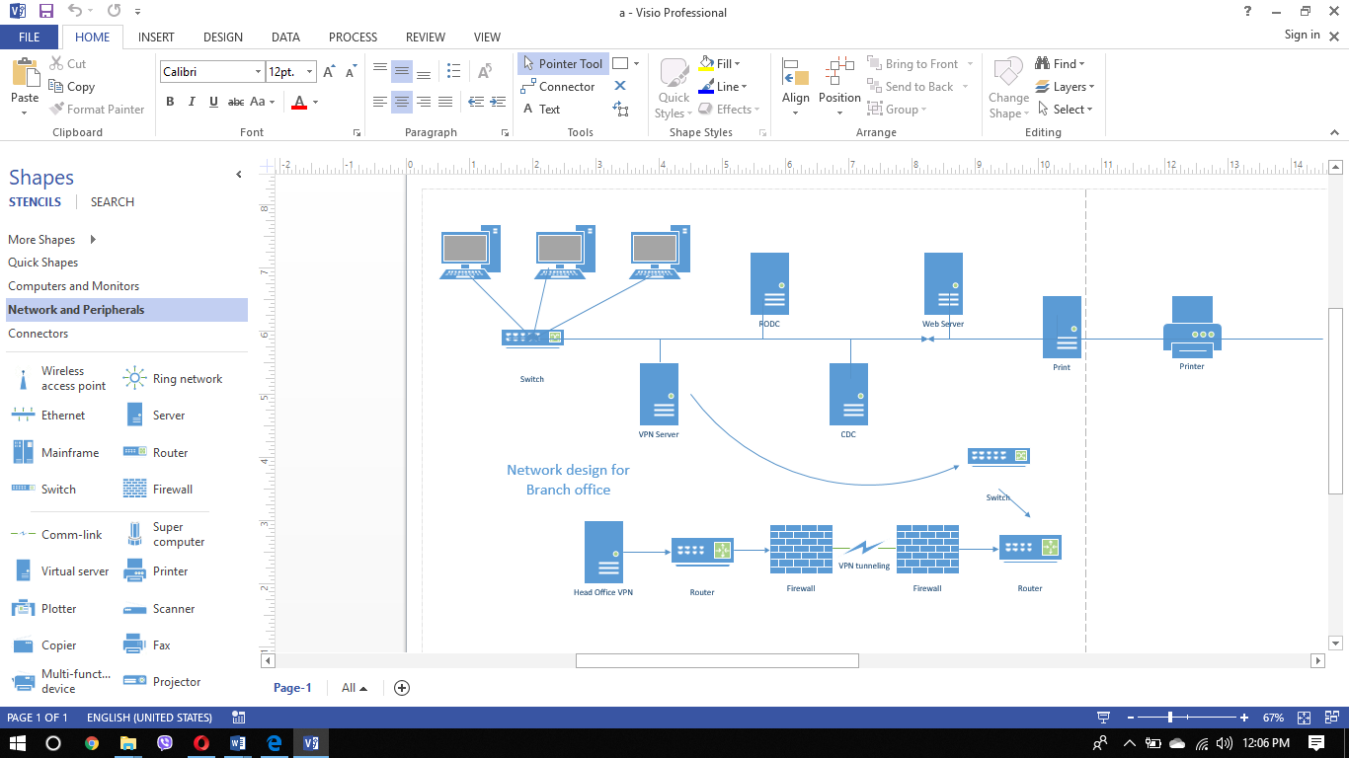

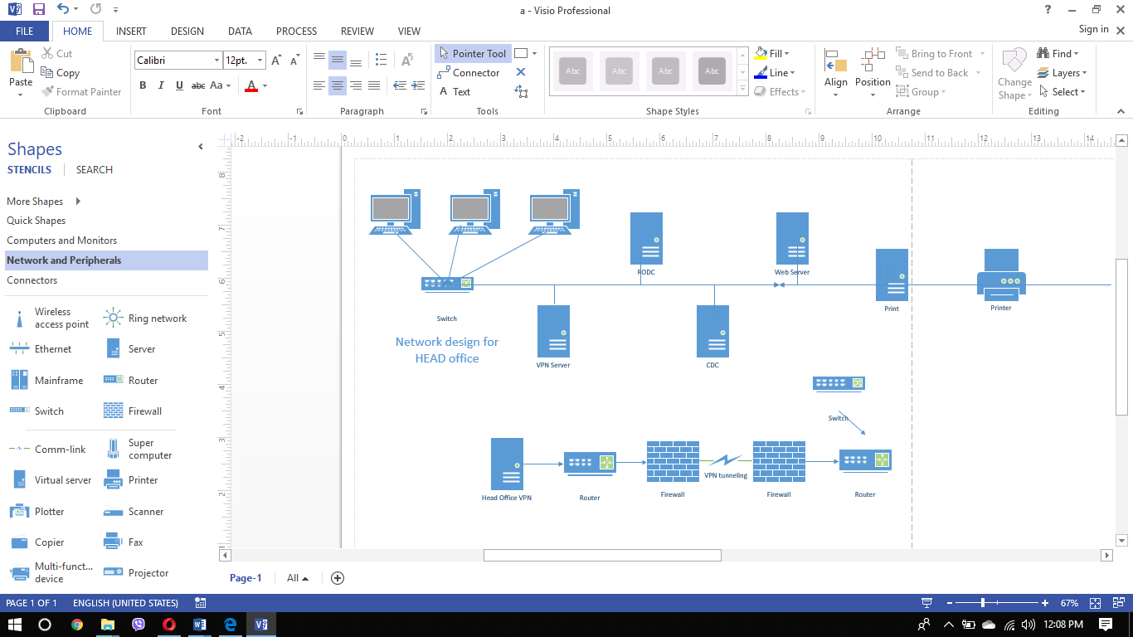

IP TABLE OF HEAD OFFICE (ALL SERVER UP TO NOW)

|  |  |  |  |  |  |
| --- | --- | --- | --- | --- | --- |
| SN | SERVER | IP | SUBNETMASK | GATEWAY |  |
| 1 | DC | 192.168.100.2 | 255.255.255.0 | 192.168.100.1 |  |
| 2 | DHCP | 192.168.100.3 | 255.255.255.0 | 192.168.100.1 |  |
| 3 | DNS | 200.150.100.1 | 255.255.255.0 | 192.168.100.1 |  |
| 4 | IIS | 192.168.100.5 | 255.255.255.0 | 192.168.100.1 |  |
| 5 | PRINT | 192.168.100.6 | 255.255.255.0 | 192.168.100.1 |  |

IP TABLE OF BRANCH OFFICE (ALL SERVER UP TO NOW)

|  |  |  |  |  |  |
| --- | --- | --- | --- | --- | --- |
| SN | SERVER | IP | SUBNETMASK | GATEWAY |  |
| 1 | RODC | 192.168.101.16 | 255.255.255.0 | 192.168.100.1 |  |
| 2 | CDC | 192.168.101.17 | 255.255.255.0 | 192.168.100.1 |  |
| 3 | WDS | 192.168.101.4 | 255.255.255.0 | 192.168.100.1 |  |
| 4 | FTP | 192.168.101.25 | 255.255.255.0 | 192.168.100.1 |  |

# Server used on network design:

1. ADDS: Active Directory Domain Services is a server function in Active Directory that allows admins to manage and store network information in a distributed database on property and application data. Active Directory Domain Services (ADDS) can also help administrators in handling and translating network parts (pcs and end-customers) into a particular framework.
2. DHCP: The DHCP server can provide IP addresses to clients automatically to avoid the setup and setup of options on the client side. All we have to do is set up DHCP servers, set range options, and some other TCP / IP server settings. We have installed IPs from the selected spectrum and our clients can be supplied with some other TCP / IP options.
3. DNS: DNS retains and connects a domain name to IP addresses. This is essential as while domain names are easy to maintain in mind when accessing IP-based databases for people, computers or machines.
4. IIS: IIS is one of the most powerful web servers used by Microsoft to host our web application. The IIS has its own system engine to process the application. If a application from a client to a server is obtained, IIS will process and return a response to the client.
5. PRINT server: We use a Lanmark IT print server that can be very helpful in a scenario where many individuals share a closed network of pcs that will write to the same machine. This is especially true for the environment of an office or a college. Print server features include supplying all linked client pcs with print supplies and storing print orders in a queue until they are prepared to be printed by the printer.
6. RODC: The primary reason to use an RODC is mainly for safety reasons, while offering domain resilience in distant headquarters as well. If their server is stolen or hacked, RODC can play a key role in securing remote offices and not jeopardizing the security of a business.
7. CDC: Another domain under a parent domain is a child domain in the active directory domain hierarchy. A baby domain is a tree under a parent's first root domain. All trees occur in a forest ; a forest is the boundary of safety.
8. FTP: FTP is used to move network documents between computers. You can exchange files from your computer accounts using FTP, move files from your account to your desktop, or access your online archive of software.

## Devices used

1. router: I used the router in Lanmark IT branches. It enables forward data packets between computer networks. Routers conduct traffic management tasks in our network. The existence of a router in our scheme also enhances safety.

2. Switch: I used switch at head offices to connect computers and various servers. But I used a switch to connect to the VPN server in the head office. Downstream devices are de-energized to protect them from system failures.

3. Firewall: I used firewall in our network design for safe communication at branch offices and detected unlawful activity. A firewall between the PC and the network device operates as a obstacle or shield.

4. Cable: To create communication between entire networks, I used cable and connectors on separate nodes. To solve mistakes and faults, I choose protected twisted pair cable for cable.

# Testing of design(testing only server)

## 1.test of ADDS

|  |  |  |  |  |
| --- | --- | --- | --- | --- |
| SN | DATE | WHAT WAS TESTED | EXPECTED OUTPUT | ACTUAL OUTPUT |
| 1 | 7TH APRL 2018 | ADDS | When we type dsa.msc then user name should be shown | These requirements have been met successfully because name is shown. |

## 2. test of DHCP

|  |  |  |  |  |
| --- | --- | --- | --- | --- |
| SN | DATE | WHAT WAS TESTED | EXPECTED OUTPUT | ACTUAL OUTPUT |
| 1 | 7TH APRL 2018 | DHCP | Client should take dynamic IP | These requirements have been met successfully because client had take dynamic IP |

## 3. test of VPN server

|  |  |  |  |  |
| --- | --- | --- | --- | --- |
| SN | DATE | WHAT WAS TESTED | EXPECTED OUTPUT | ACTUAL OUTPUT |
| 1 | 7TH APRL 2018 | VPN server | The VPN connection should be set up by the client computer. | These requirements have been met successfully because the connection has been setup. |

## 4. test of PRINT server

|  |  |  |  |  |
| --- | --- | --- | --- | --- |
| SN | DATE | WHAT WAS TESTED | EXPECTED OUTPUT | ACTUAL OUTPUT |
| 1 | 7TH APRL 2018 | PRINT server | Every laptop has to share a printer. | These requirements have been met successfully because the every laptop has shared same printer |

## 5. test of WEB server

|  |  |  |  |  |
| --- | --- | --- | --- | --- |
| SN | DATE | WHAT WAS TESTED | EXPECTED OUTPUT | Remark |
| 1 | 7TH APRL 2018 | WEB server | The web page on the main server should be prepared to show web pages on the client computer. | These requirements have been met successfully because the web page has been shown on the server |

# Project title: network design & implementation of landmark it pvt.ltd.

Feedback given by: Bisesh Shrestha

Date: 17th June 2018

Signature:

## User feedback

|  |  |  |  |  |
| --- | --- | --- | --- | --- |
| SN | Questioners | yes | No | remarks |
| 1 | Is this design fulfilled the requirement of users? | Yes |  | It fulfill the requirement of users |
| 2 | Is this design is suitable for the organization? | Yes |  | It is suitable for organization |
| 3 | Is this design will be modified on different time factor? | Yes |  | It will be modified in time |
| 4 | Is this upgradeable design? | Yes |  | It will be upgraded time to time |
| 5 | Is this deign flexible? | Yes |  | It is flexile |
| 6 | Does this design have good security? | Yes |  | It have good security |
| 8 | Is it trustworthy? | Yes |  | It is trust worthy |

# Conclusion

Hence, I have provided a test log for different servers that were worn in the network design, as well as the expected output and actual output. I also correctly assessed various factors to meet the requirements of network systems and user feedback on network design.

# LAB REPORT

## DOMAIN CONTROLLER(ADDS)

A domain controller (Active directory domain service/domain server) is a server which is used to create, manage the user or group.it is a server that implement, manage and monitor different types of security policies and stores the resources of entire network.

***REQUIREMENTS for configuration of domain controller:***

1. Server OS(operating system) should be installed 1st for e.g.(windows server 2012)
2. Should be logon from administrator.
3. Static IP (for eg 192.168.100.1)
4. Active directory domain service/software(ADDS)
5. Strong password with minimum 8 characters (Including alphabets, numerical values, special characters)

***PROCESS for domain registration:***

***STEP 1***: At first static IP should be assigned.

* Press win+r to open Run in computer then type ncpa.cpl

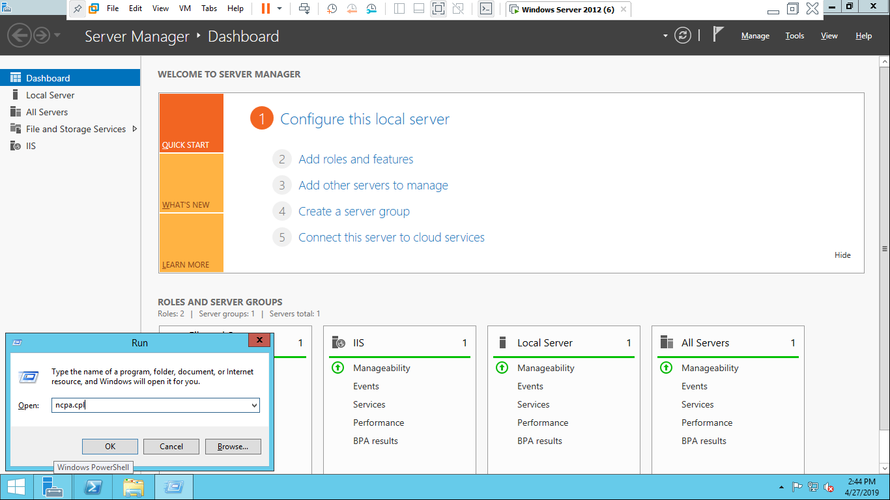

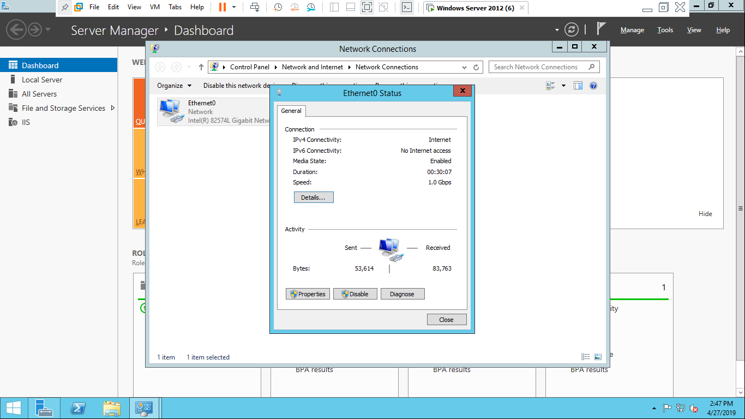

* Right mouse click on ethernet and Ethernet status box will open then click on properties.
* Ethernet properties box will appear then Click on internet protocol version 4(TCP/IPV4)

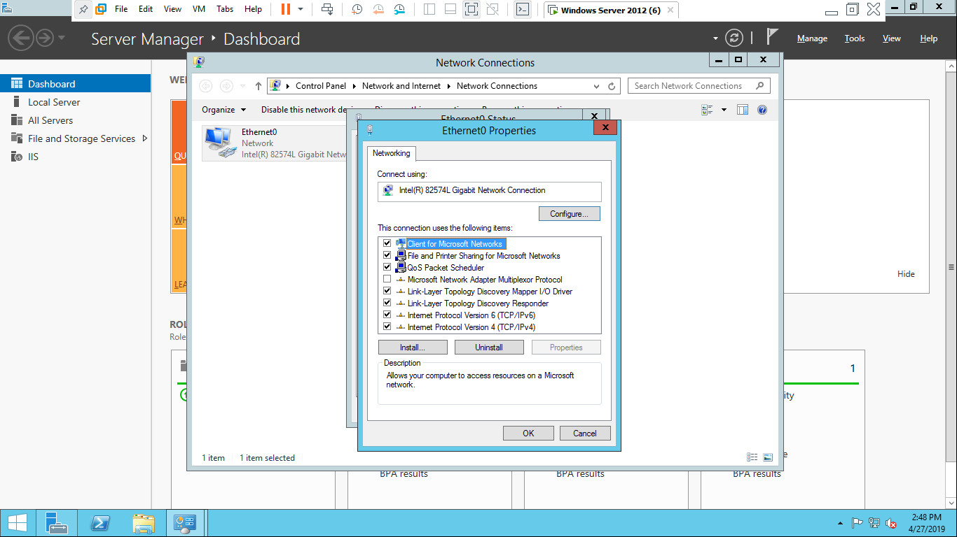

* Select option, Use the following IP address and assign the IP address, subnet mask and preferred DNS server addresses.

Preferred DNS server should be same as Domain for eg 192.168.100.1 in both IP address and Preferred DNS server . and click on ok 3 time continuously.

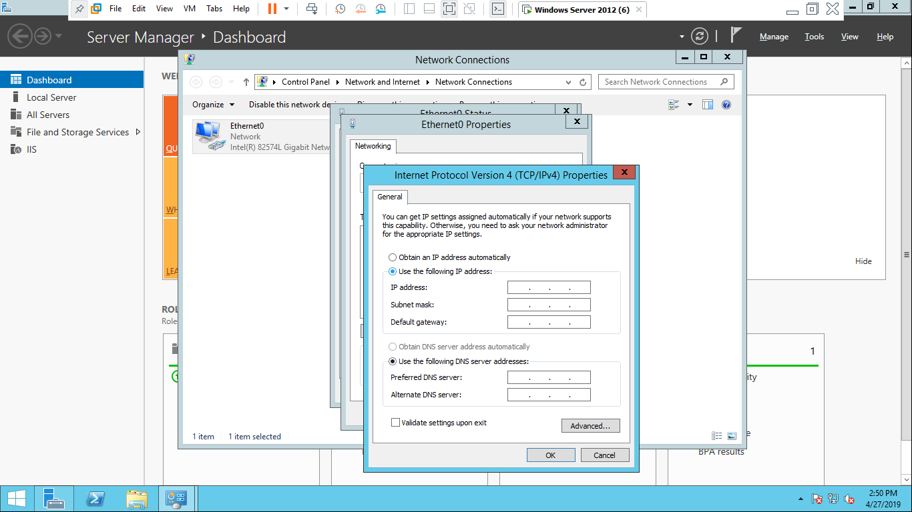

***STEP 2:*** Select network adaptor

* Go to VM settings

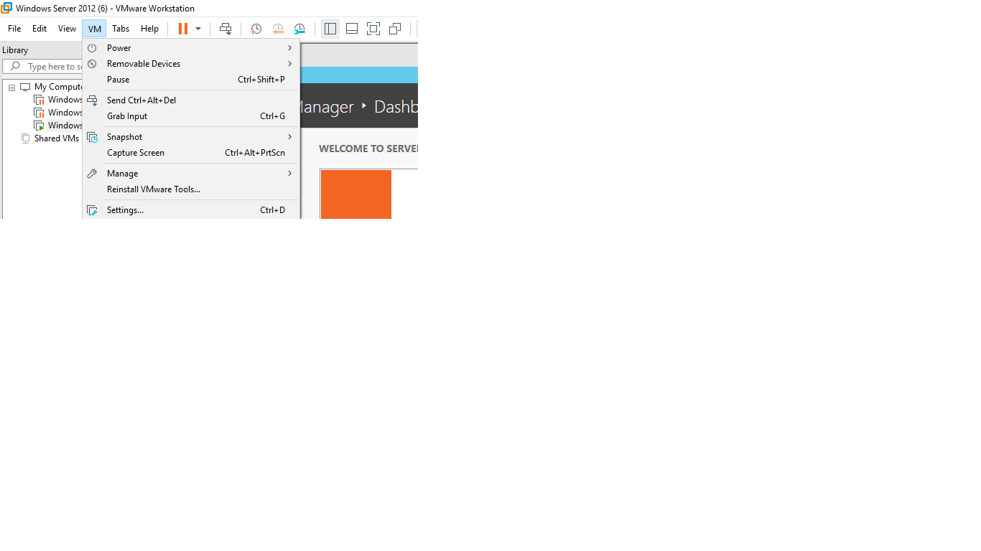

* Click on network adaptor and select or create new LAN segment and click on ok.

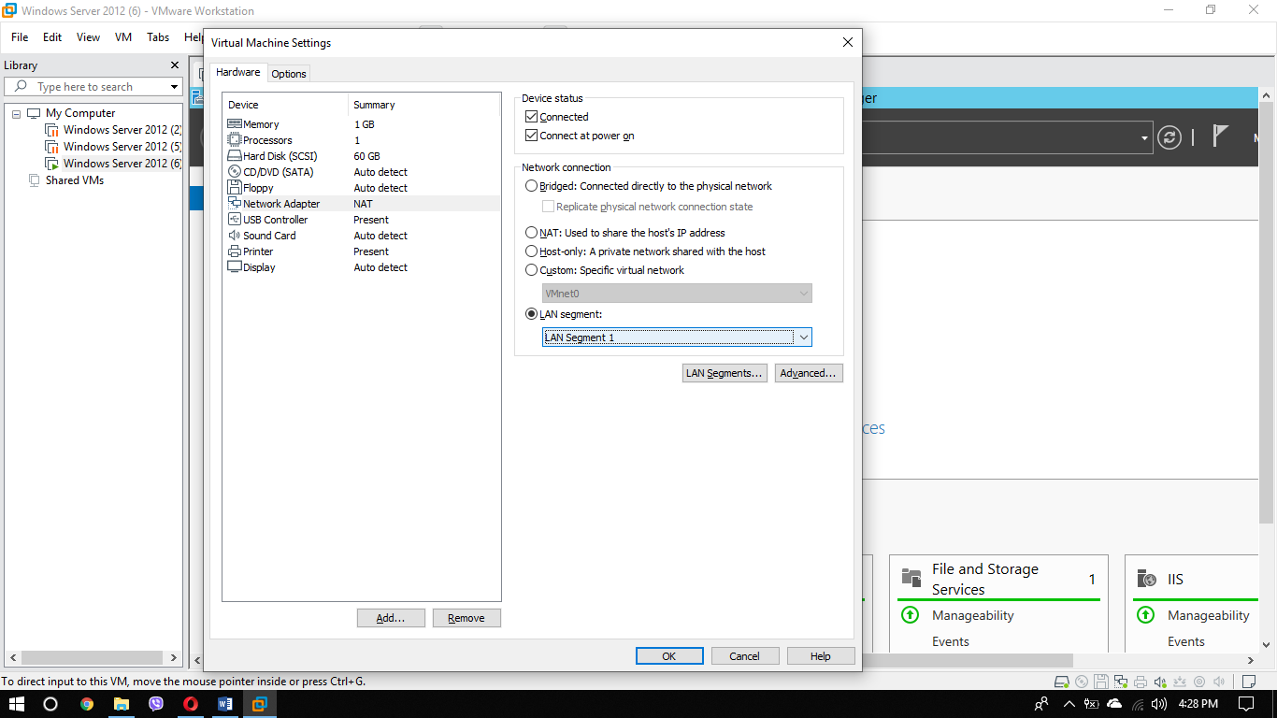

***STEP 3:*** Turn off fire wall

* Open run(win+r)and type firewall.cpl

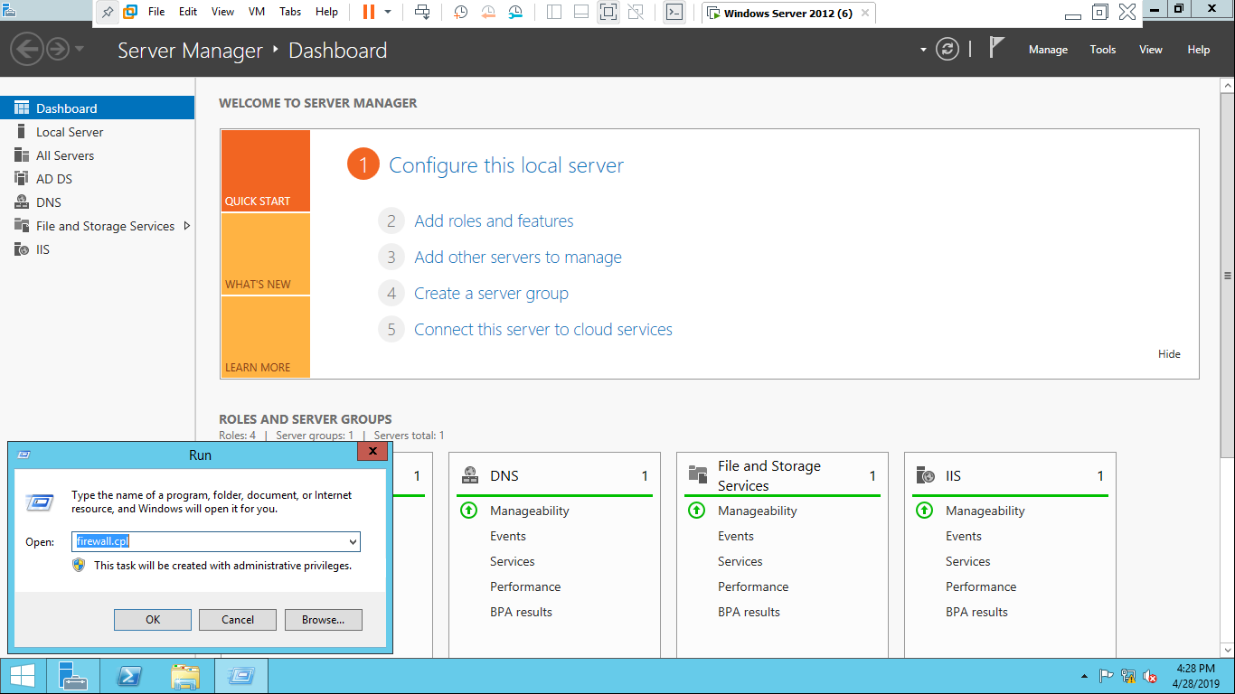

* Turn off all the firewalls and click

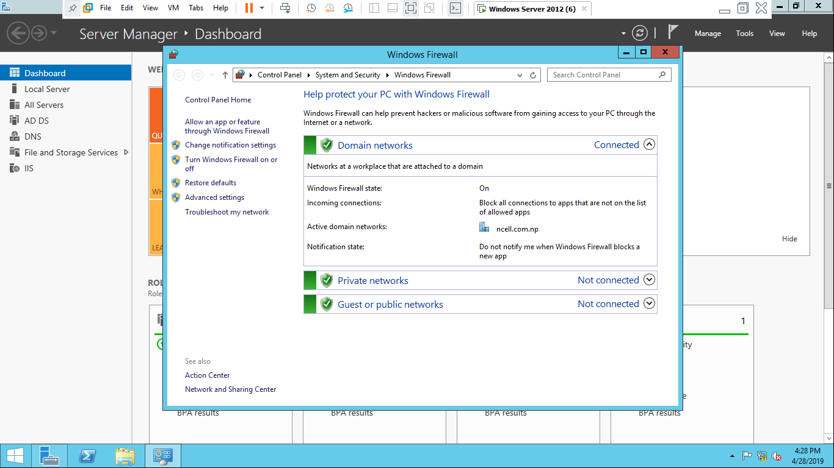

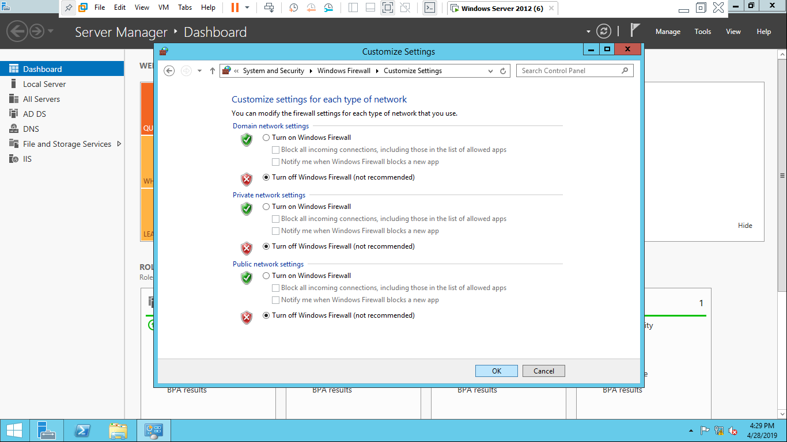

***STEP 4***: Configuration of active domain directory server

* 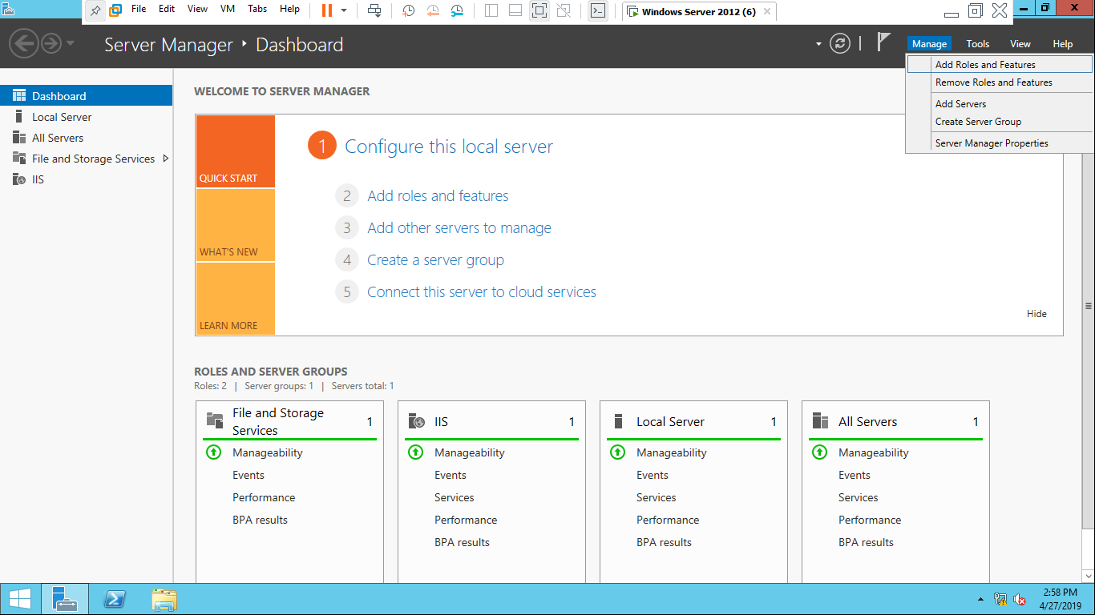Open server manager and go to manage. Then Click on add role and features
* Add role and Features Wizard box will appear then Click next three time up to Server Section.

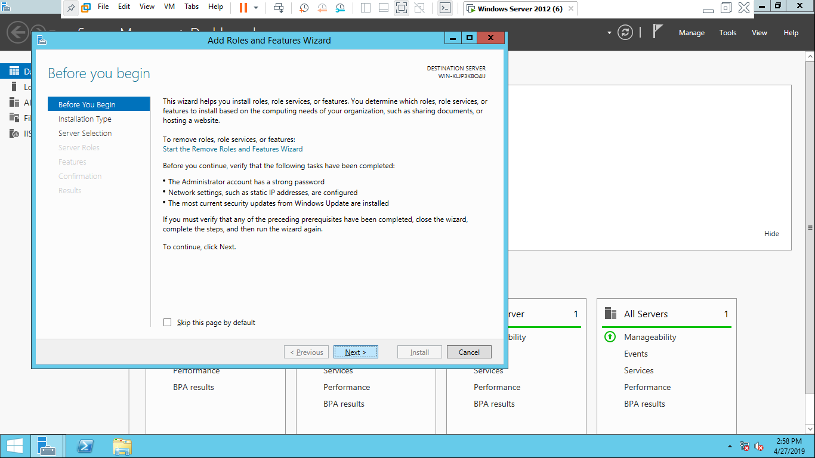

* Select Active Directory Domain Services and click on Add features. 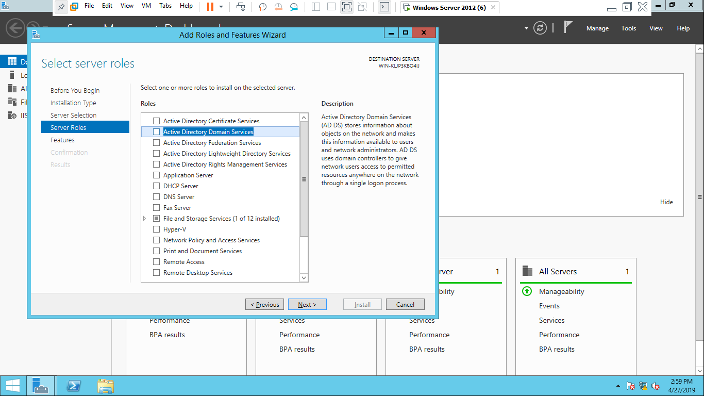

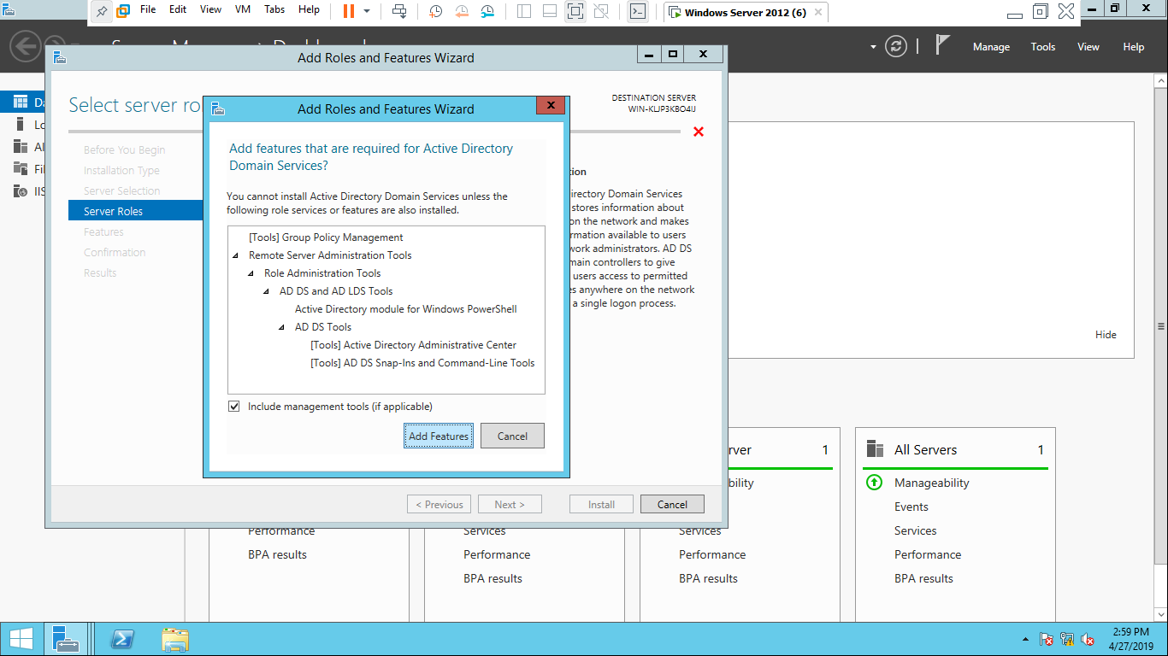

* Click Next 3 time respectively up to confirmation

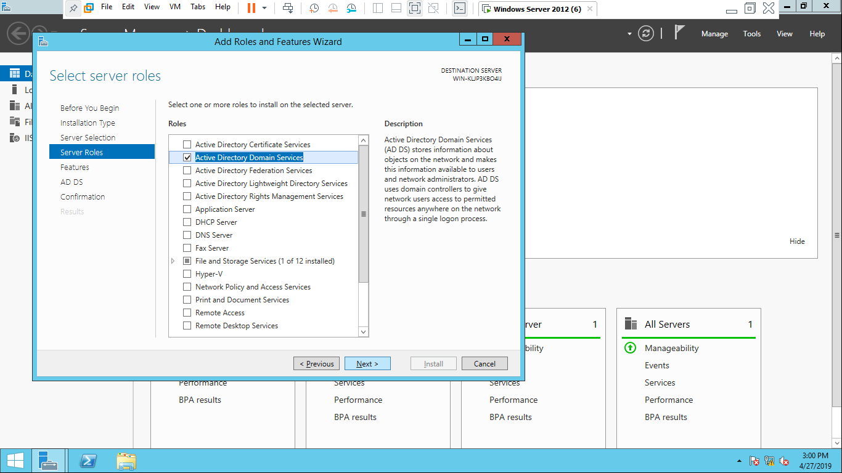

* CLICK on Restart the destination server automatically if required and then click on install button.

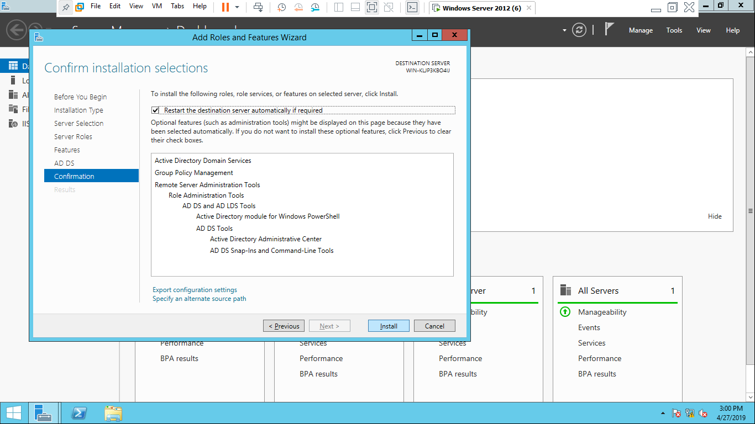

* Wait for result and click on close button. Computer may restart several time while completing the process. At last click on close button.

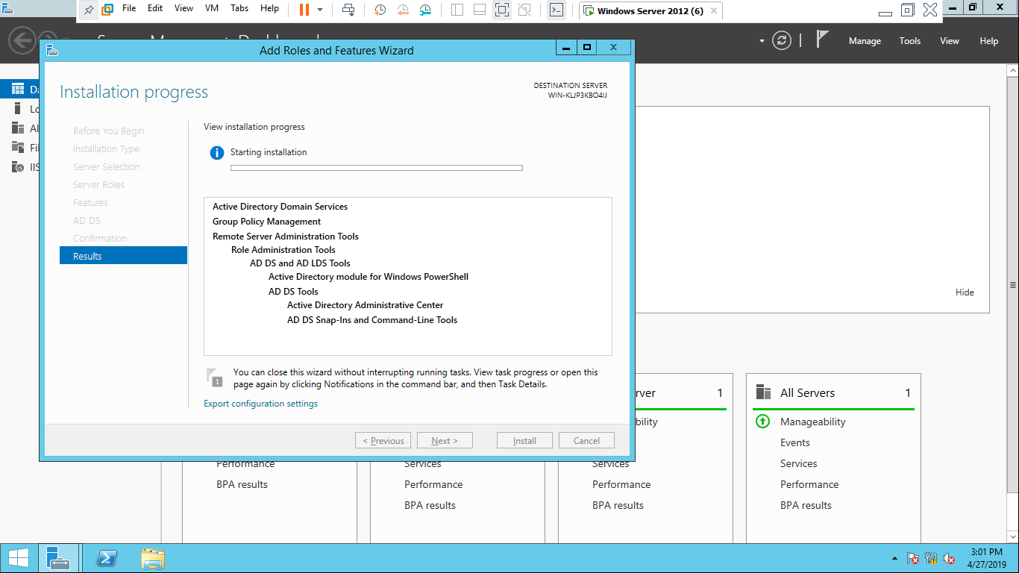

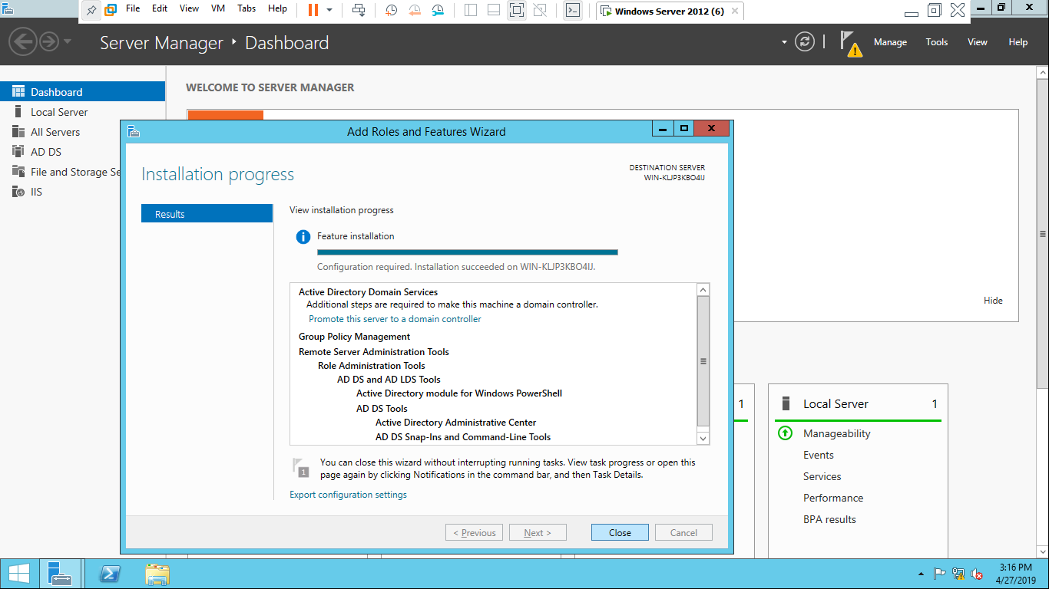

***STEP 5:*** Registration for domain controller.

* click on the warning sign and then click on promote this server to a domain controller

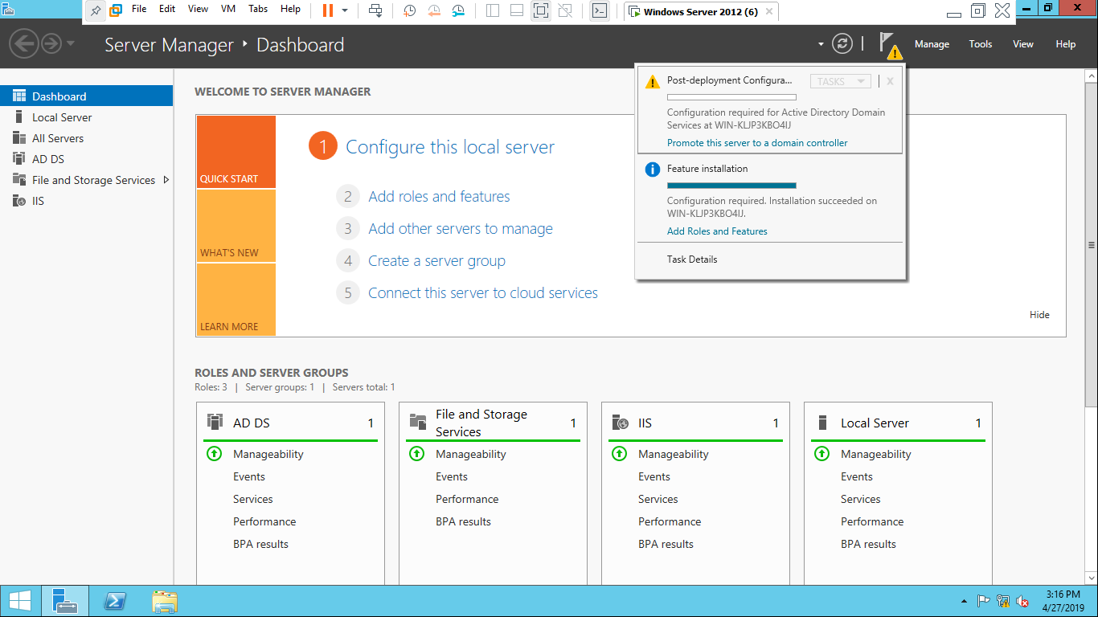

* Active Directory Domain Server Configuration Wizard will open then there will be three option where we have to select Add a new forest to register domain controller. Type Root domain name and click on Next

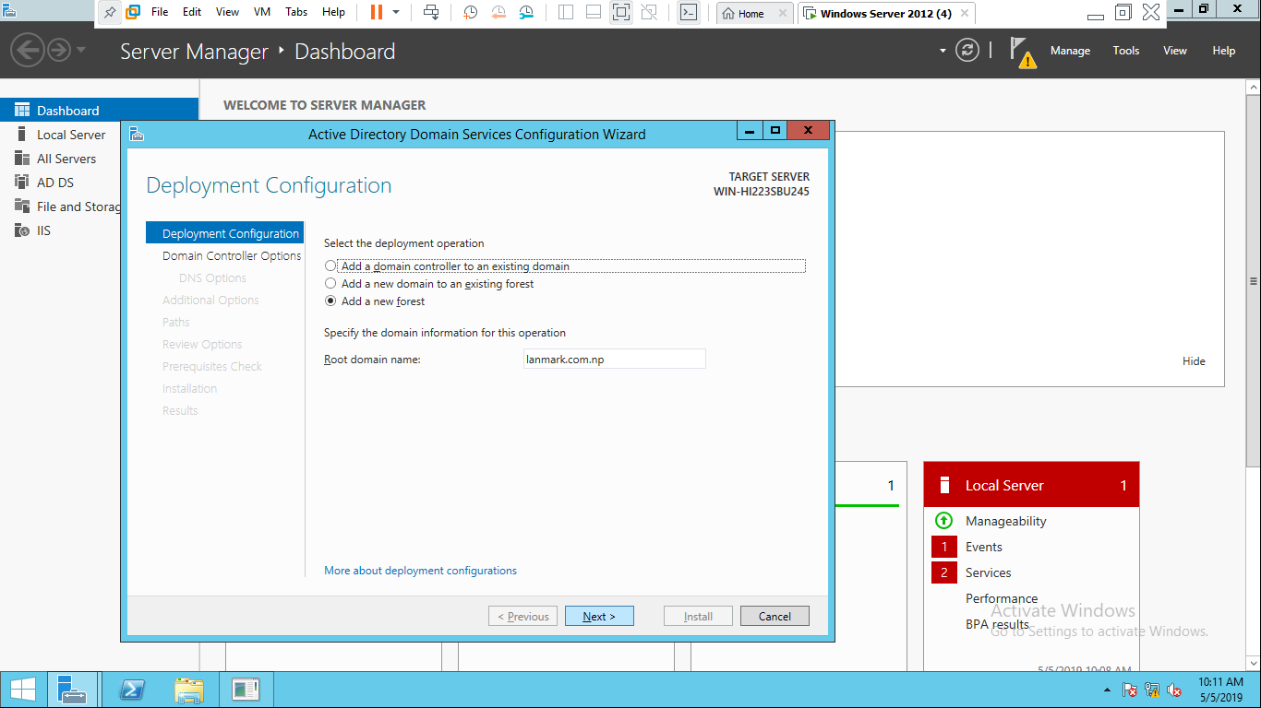

* 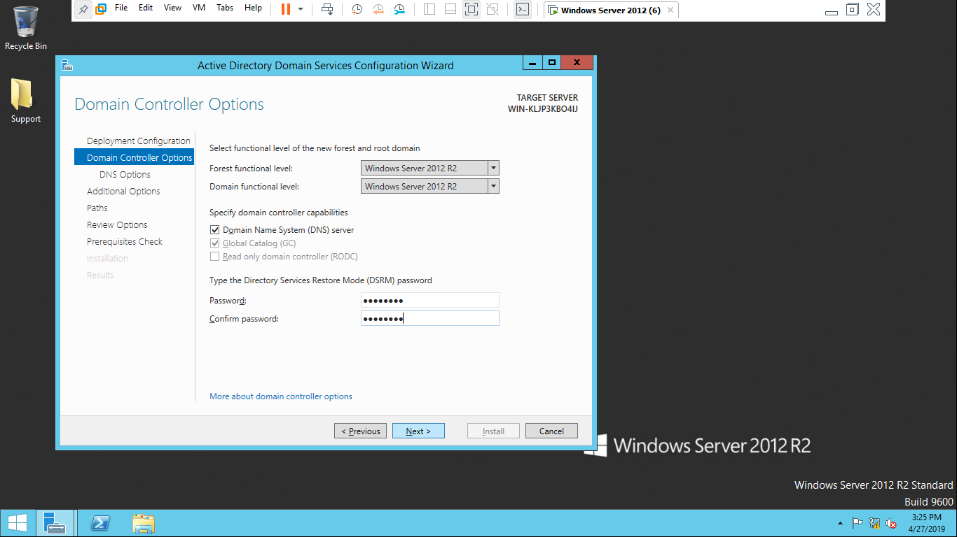Type the directory Service Restore Mode Password and then click on Next 5 time up to Prerequisites Check.
* 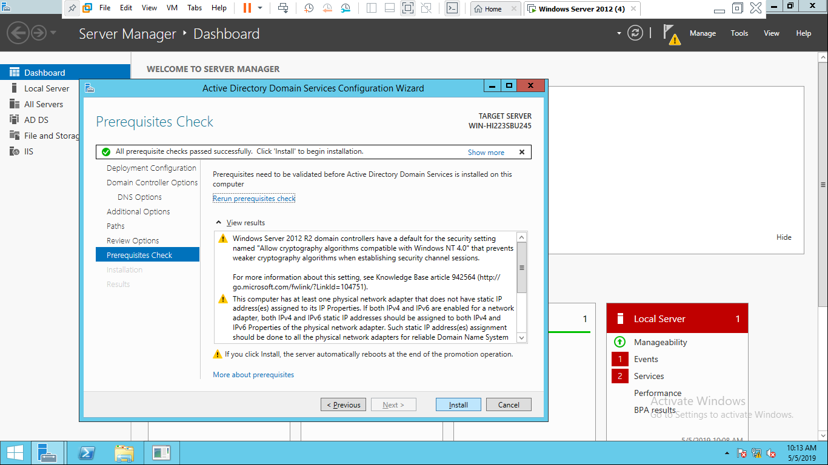click on Install and your computer will restart.
* wait for being signed out and after signed out you have successfully registered domain.

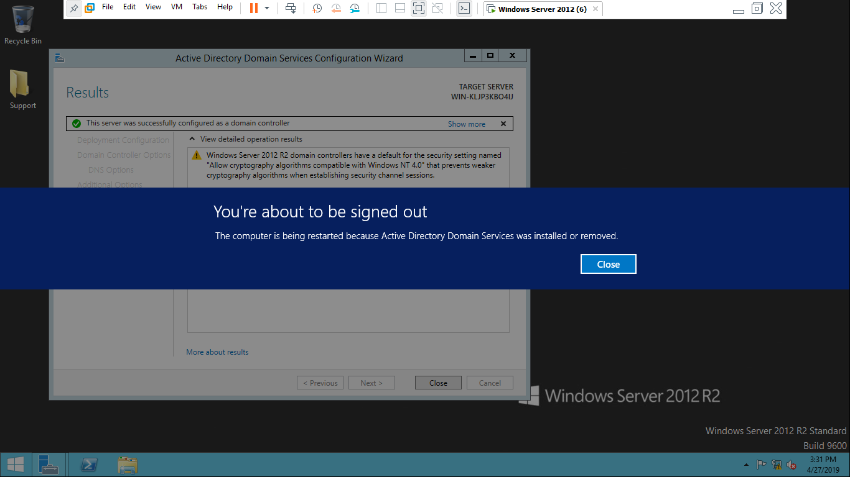

## Domain Name System(DNS Server)

DNS server is a type of server which manage, maintains and processes internet domain names and their records. It is also a server which provides IP addresses to the websites. This type of server is used by web hosting companies.

***REQUIREMENTS for configuration of DNS:***

* Server OS
* Static IP
* DNS server services

***PROCESS for DNS server:***

***STEP 1***: Configuration of active DNS server

* Step 1:Configuration
* Open server manager and go to manage then select add roles and features.

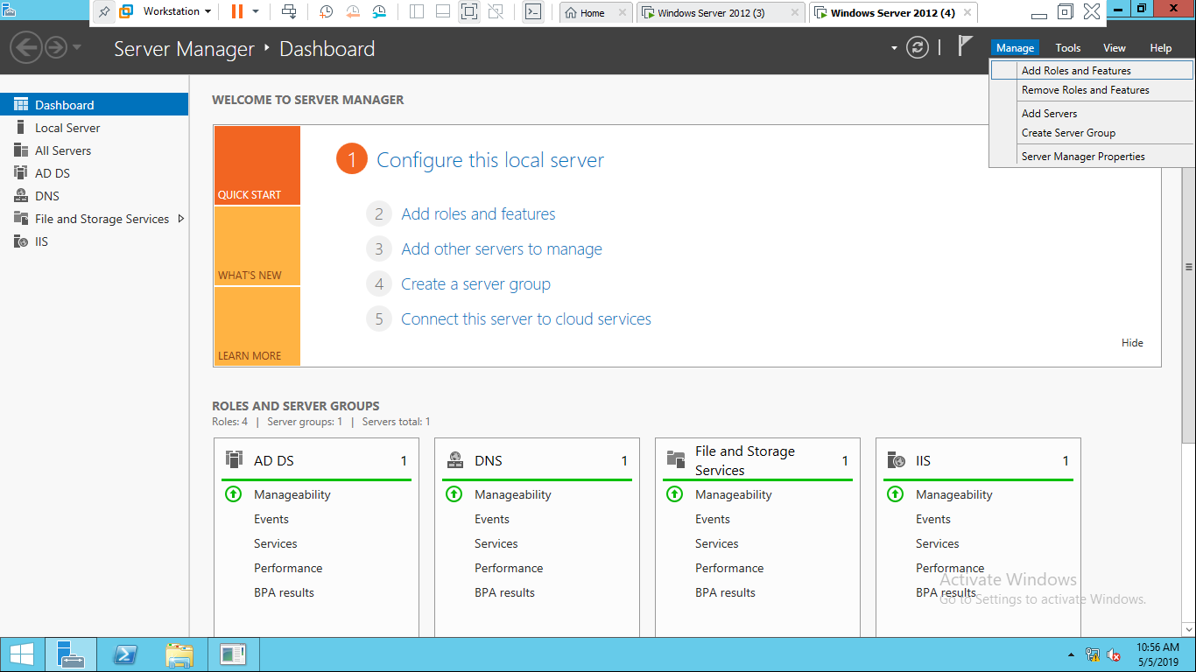

* Adds roles and feature wizard box will appear then click next three times.

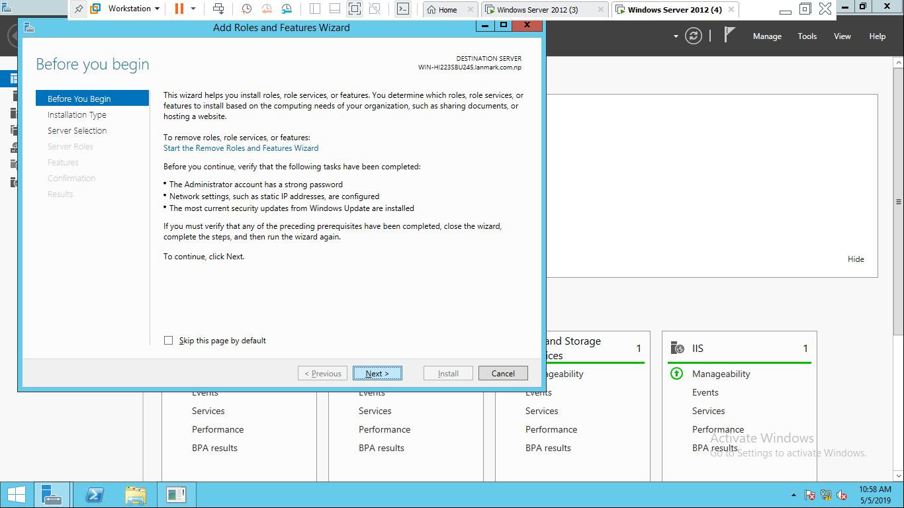

* Select DNS server

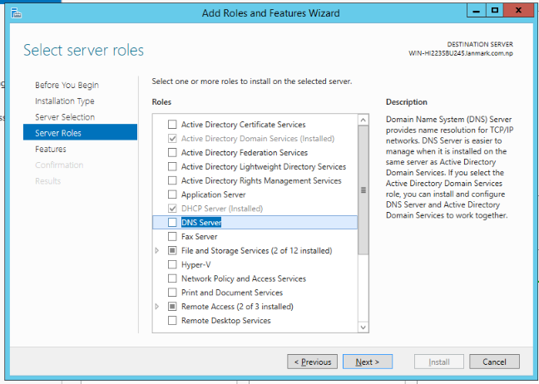

* Then click on add feature.

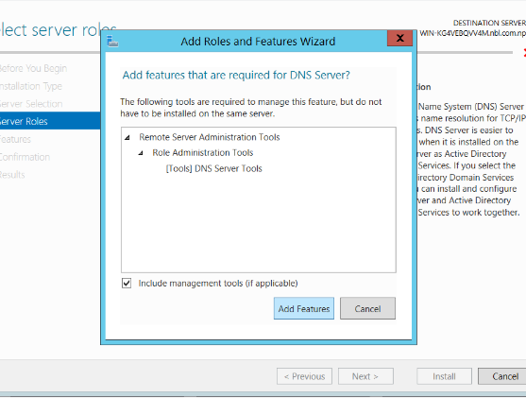

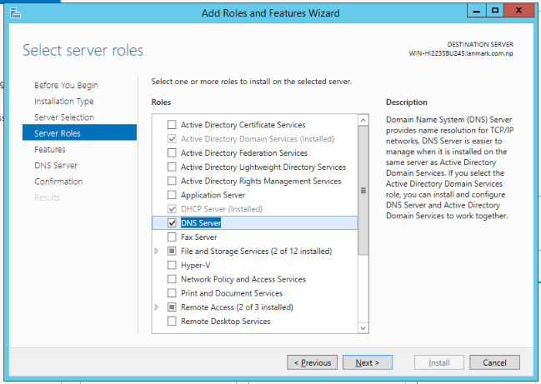

* 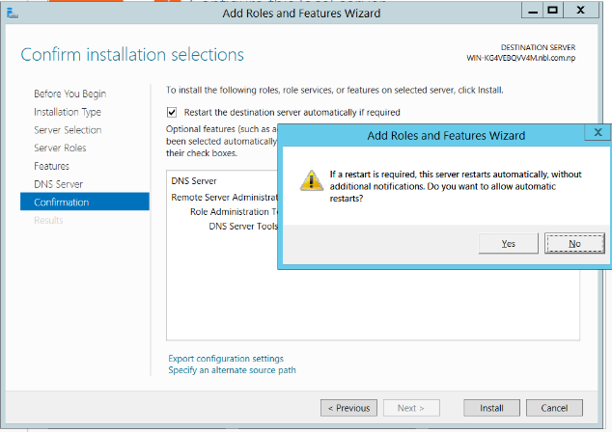Click next three times until then select Restart the destination server automatically if required then select install option.
* Installing process may take some time and the computer may restart several times then after the initialization is finished click close button.

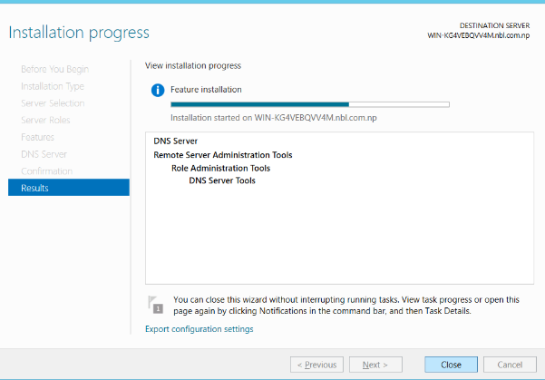

* Go to tools in server manager and click on DNS

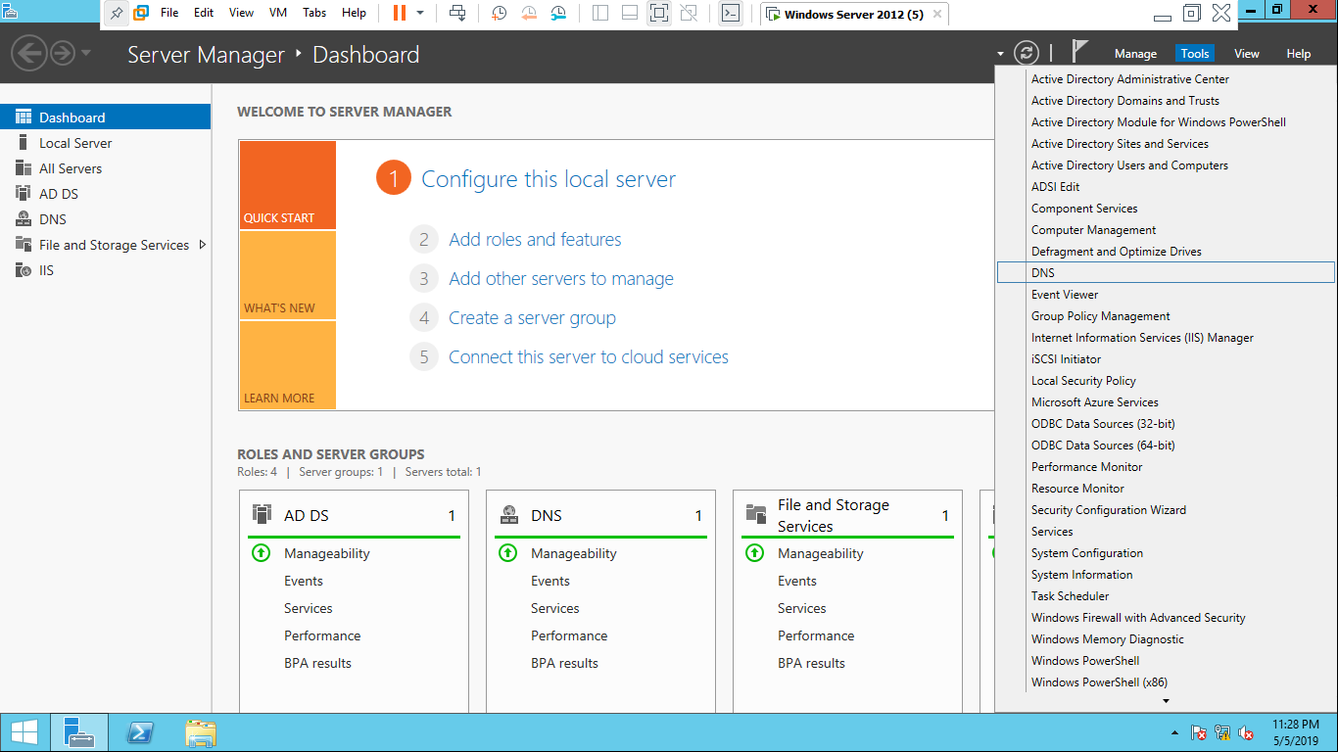

* Right mouse click on forward lookup zone and click on add new zone

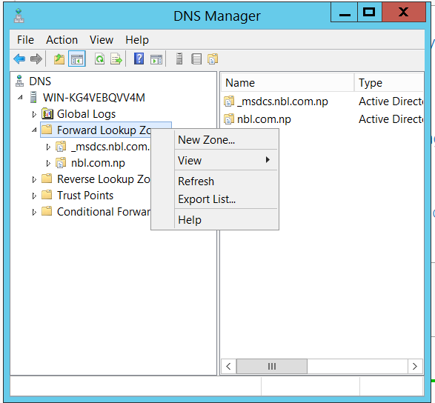

* Click next three time continuously and enter zone name as shown in picture

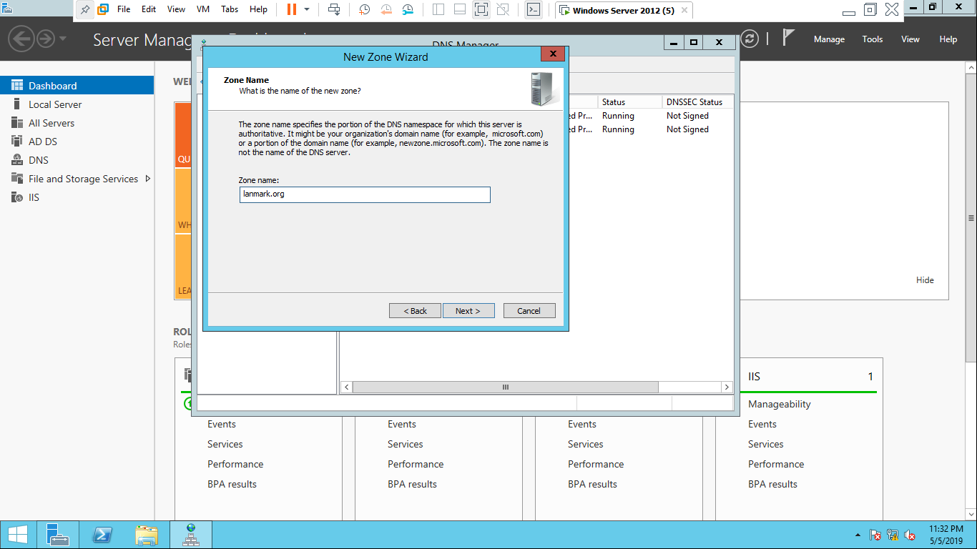

Lanmark.com.np

* Click next and click on finish

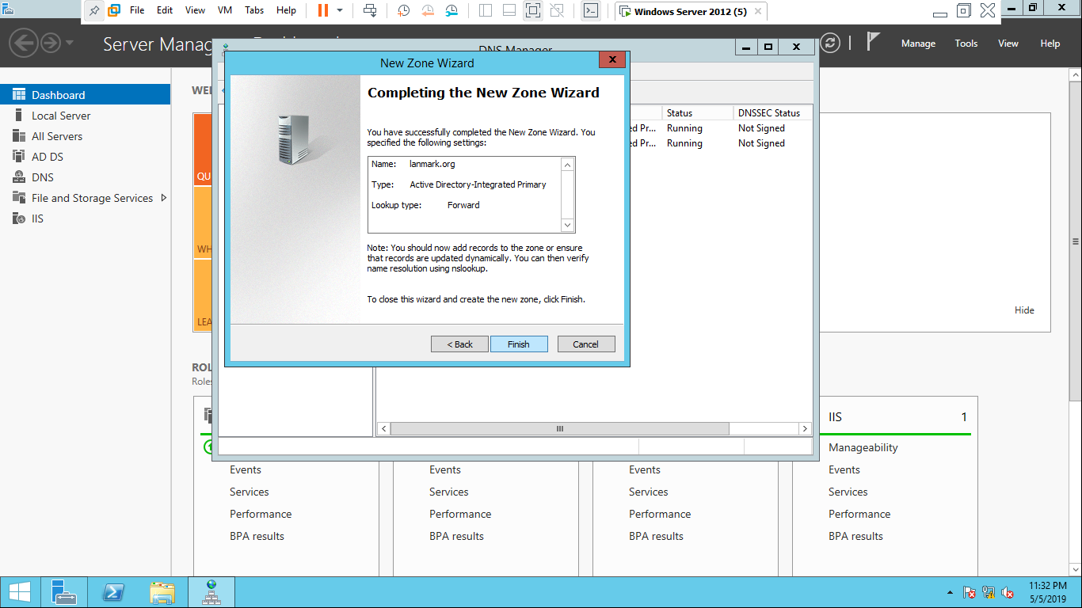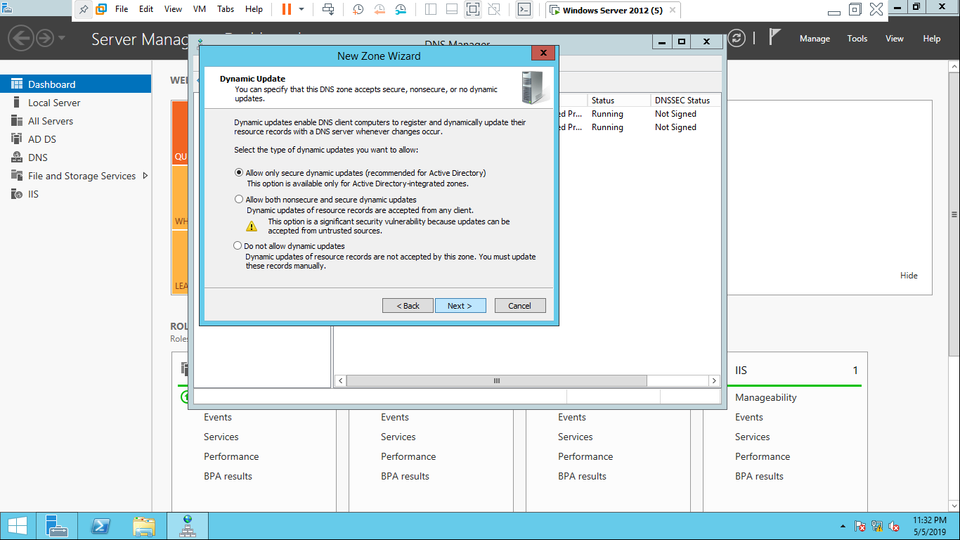

* ***step 2:*** right mouse click on reverse lookup zone >click on add new

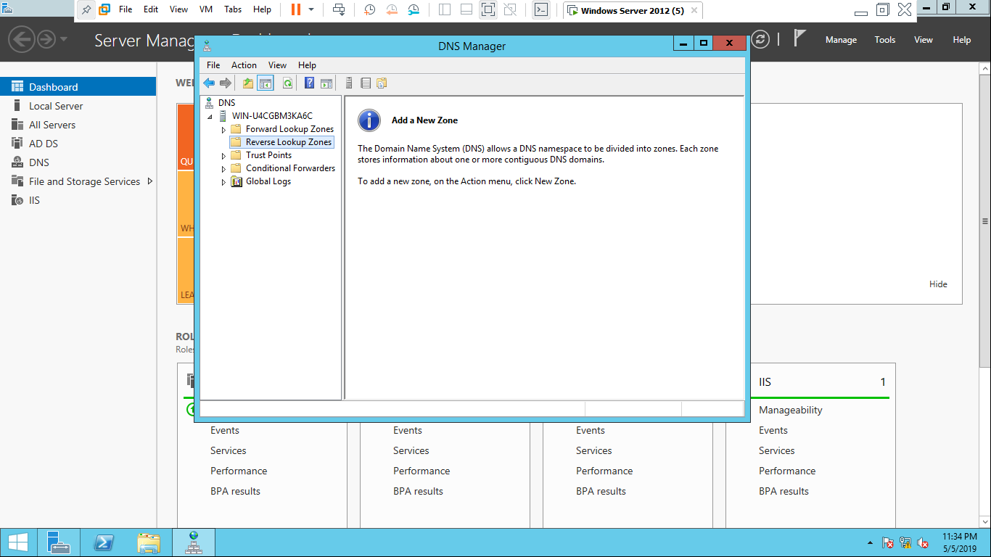

* click next > select primary zone>click next>select IPv4 Reverse lookup zone

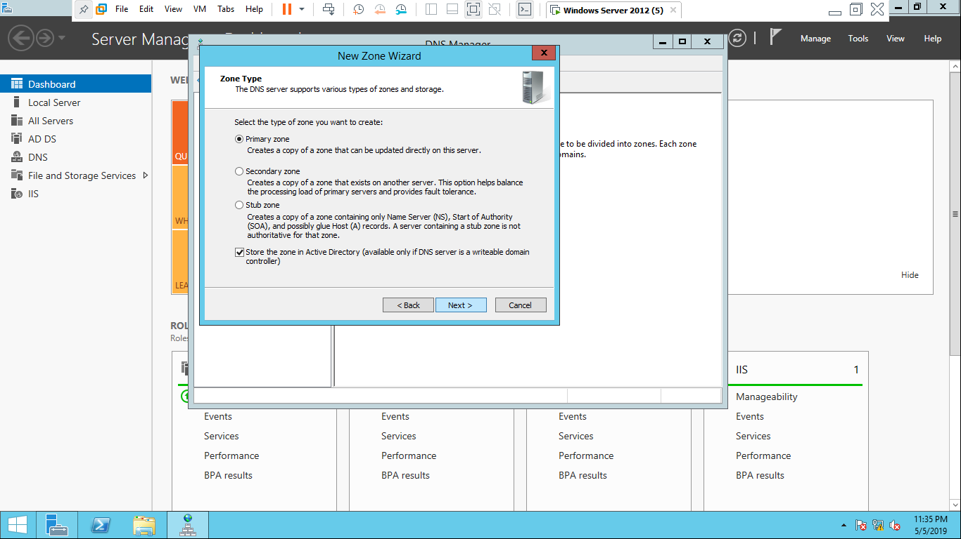

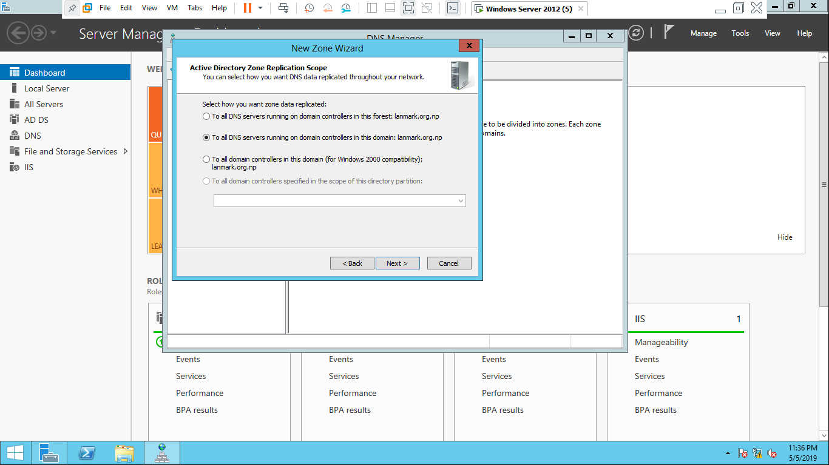

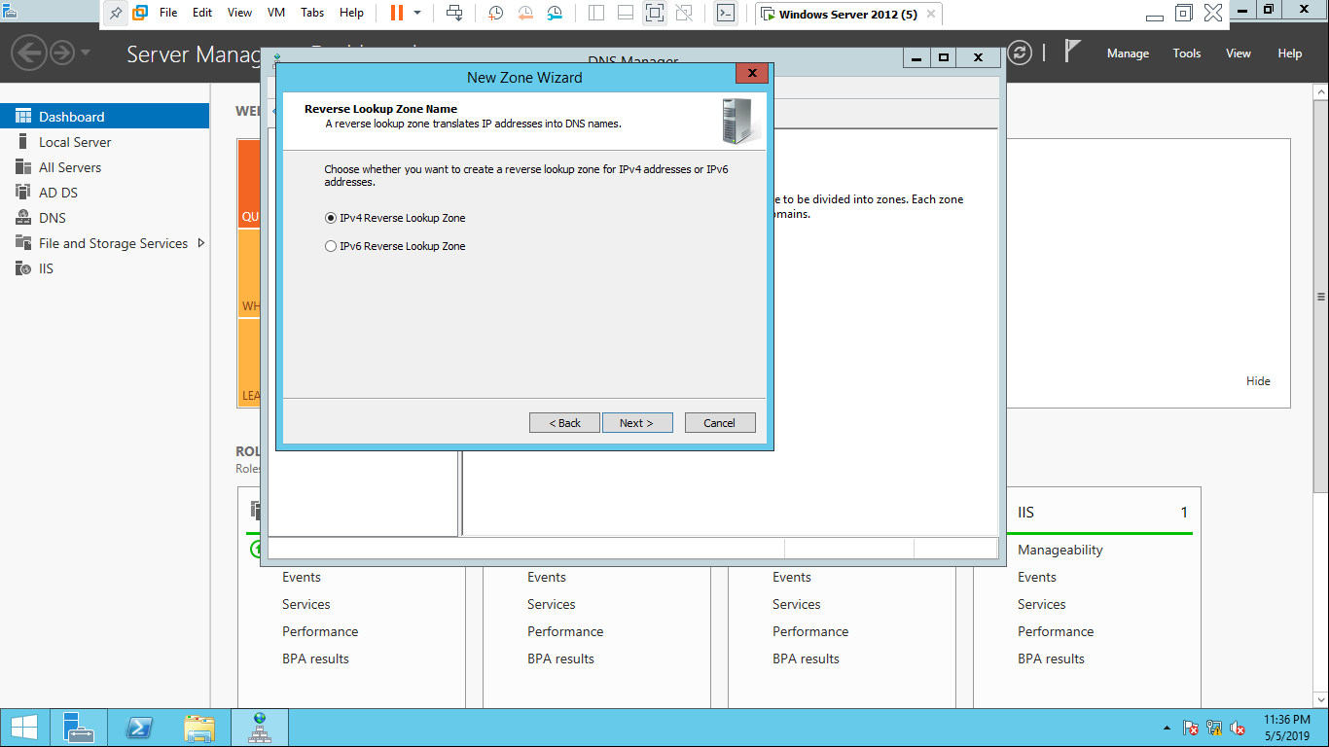

* 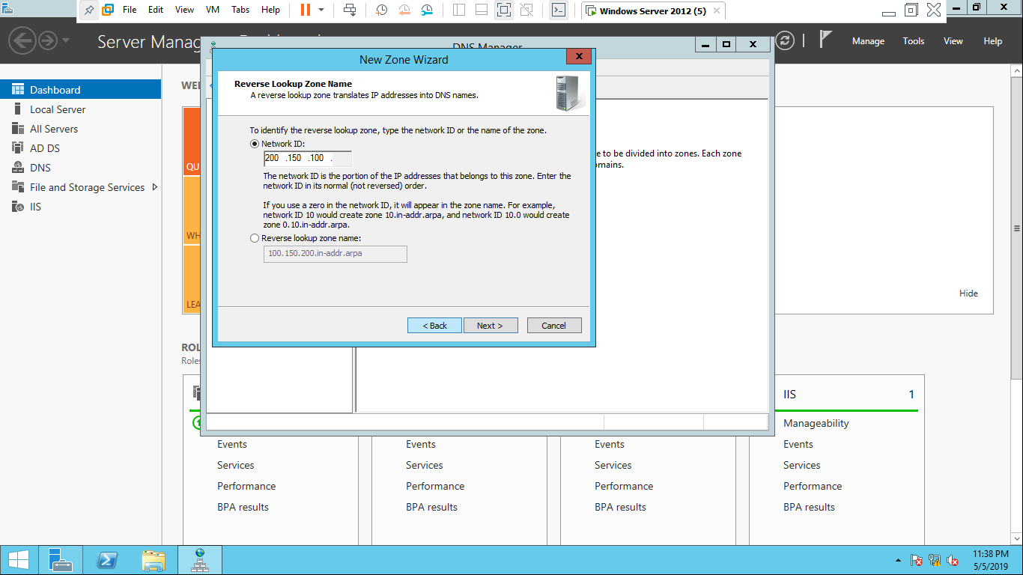Enter network ID and click on next button
* Click next and at last click on finish

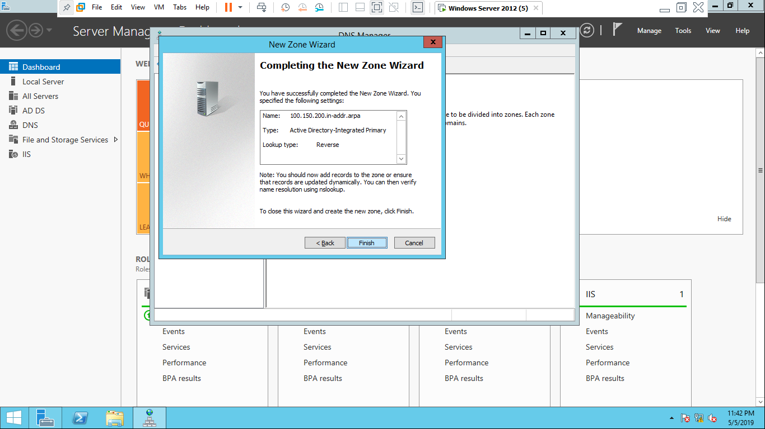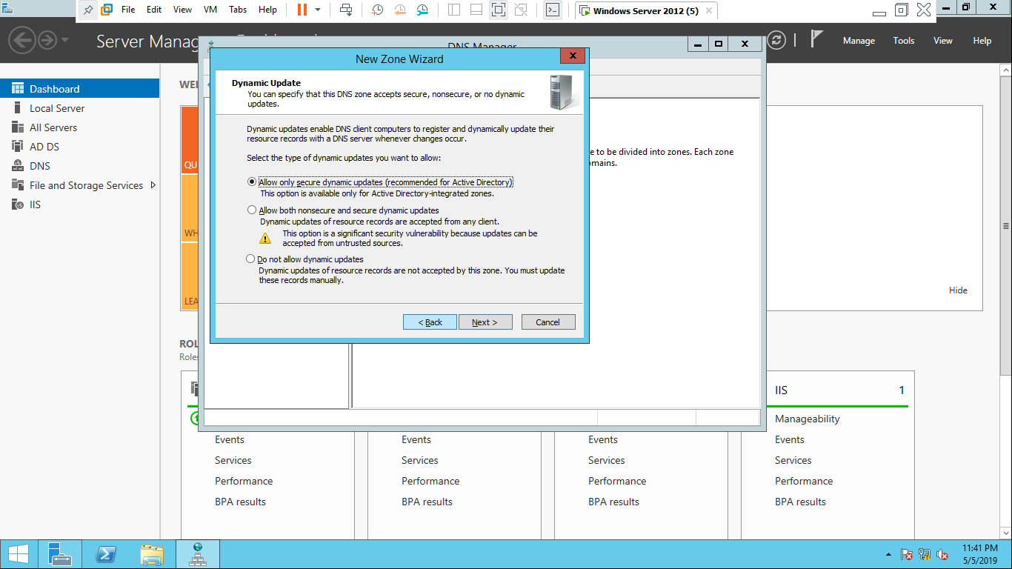

***Step 3:*** Press win+r to open Run in computer then type ncpa.cpl



* Right mouse click on ethernet and Ethernet status box will open then click on properties. 



* Ethernet properties box will appear then Click on internet protocol version 4(TCP/IPV4)
* internet protocol version properties box will appear and click on advance then click on add button

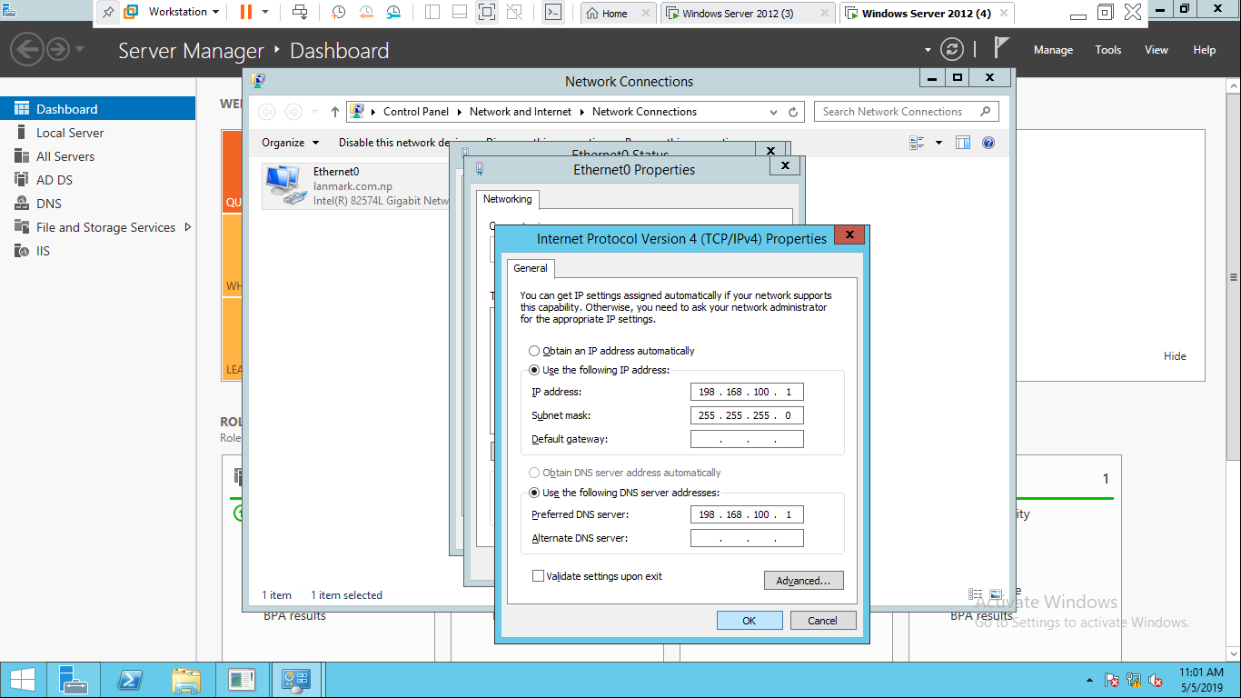

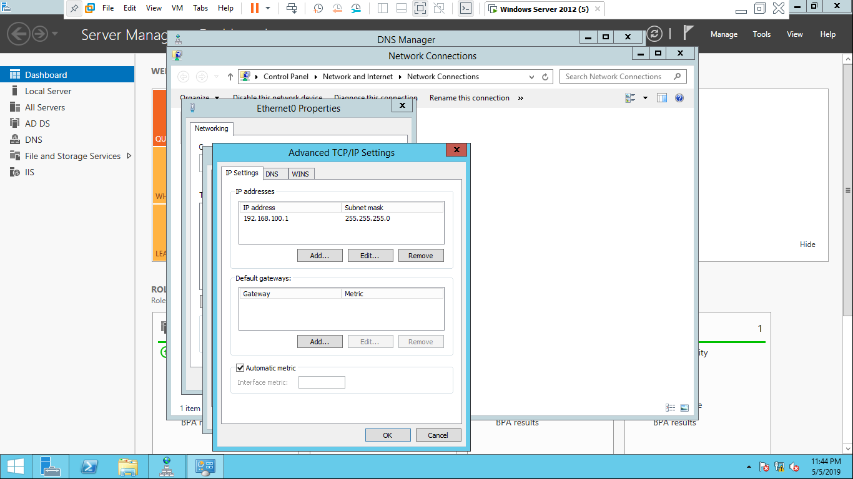

* Enter IP address(Network id) which you had entered in reverse lookup zone and click on add then click on ok 3 times respectively.

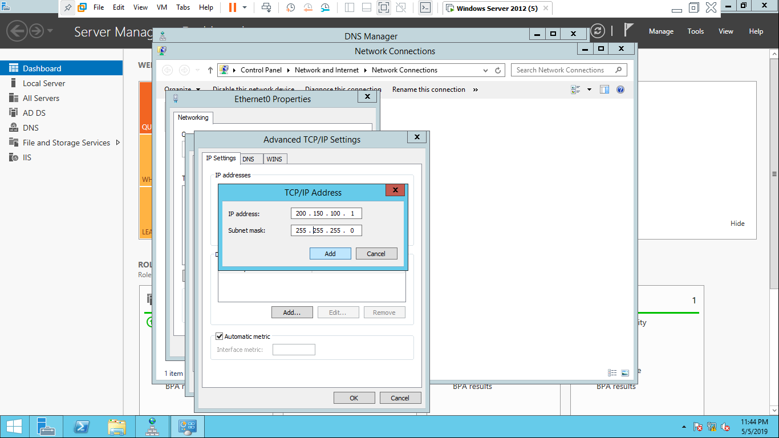

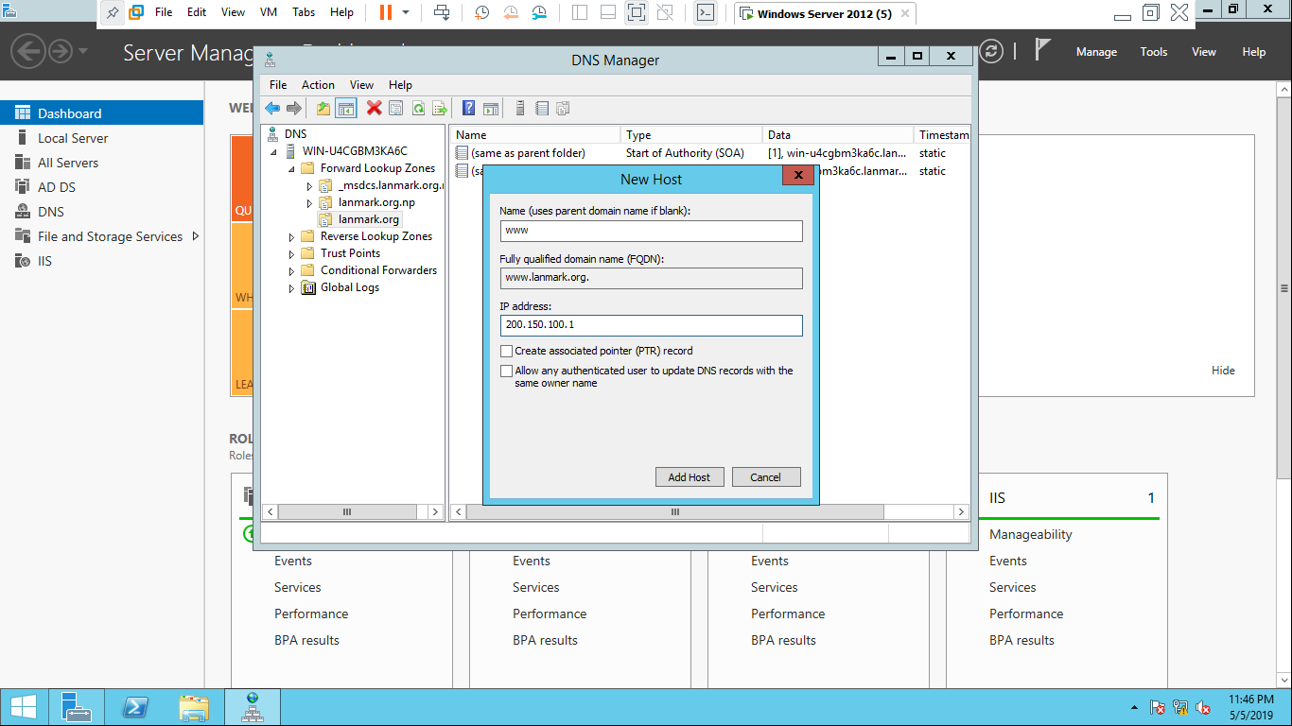

***Step 4:*** open DNS manager > double click on forward lookup zone> right mouse click on landmark.com> click on new host >write www only on name and enter IP address as you had entered in ipv4 advance setting

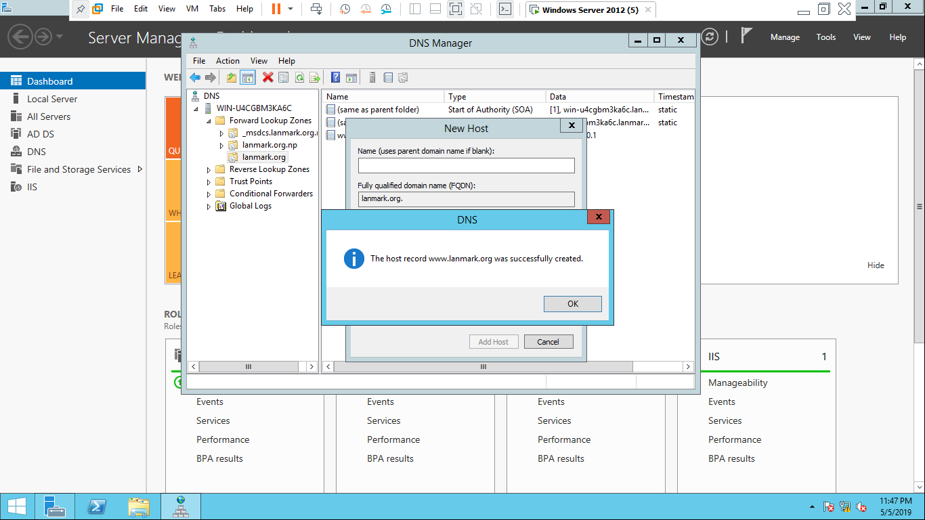

## Internet information Services(IIS) Server

IIS server is a flexible, general-purpose web server which allows web server to share and deliver information across local area network(LAN) and wide area network(WAN).

**REQUIREMENTS for configuration of IIS Server:**

* Server OS
* Static IP
* DNS server services with websites
* IIS server services

**PROCESS for IIS server:**

**Step *1:*** open server manager > click on tools > select internet information services(IIS) manager.

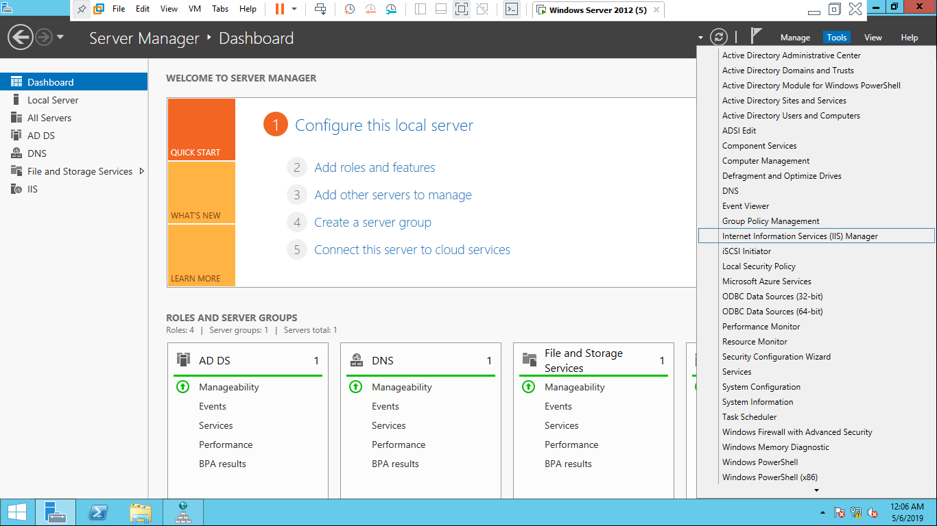

* Internet information services (IIS) Manager will open then click right mouse click on computer name(WIN-U4SC……….) >CLICK on add website

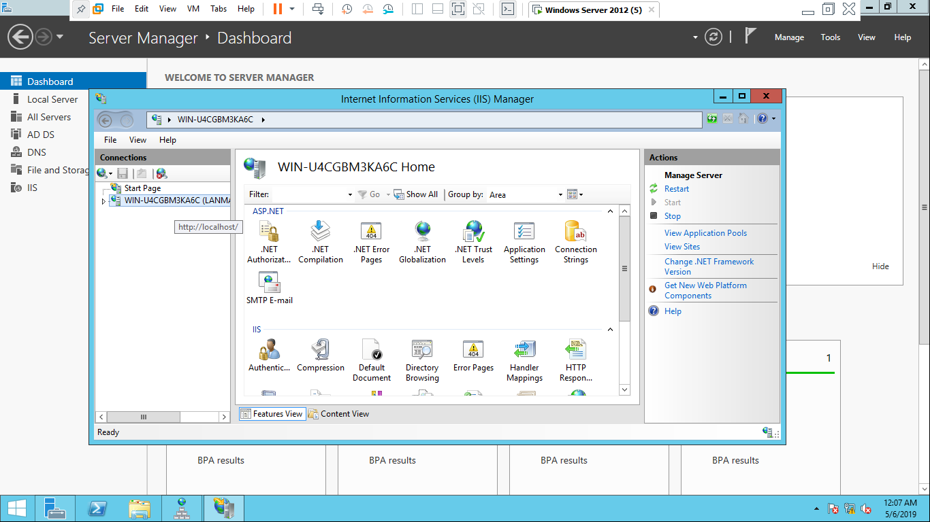

* Create webpage which we have to create using .html in a folder.

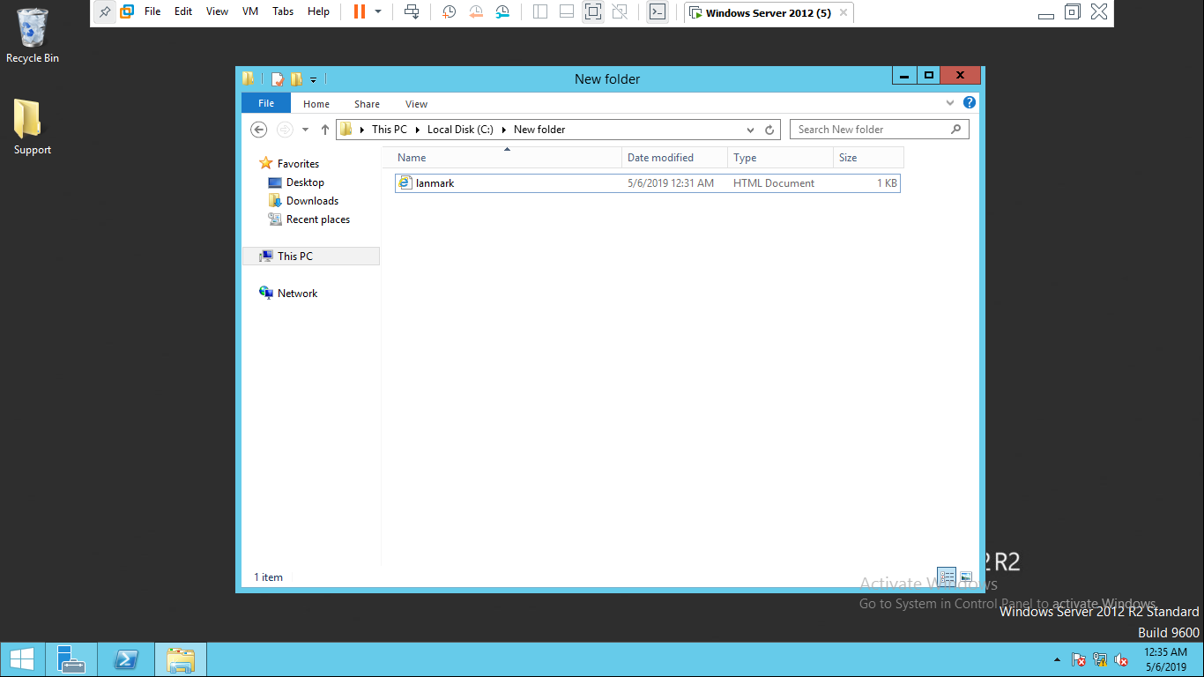

* Enter site name(www.lanmark.com) which we had created in DNS server>browse that folder in which .html file is created in physical path.> enter IP address which is use in website (200.150.100.1) and click on ok

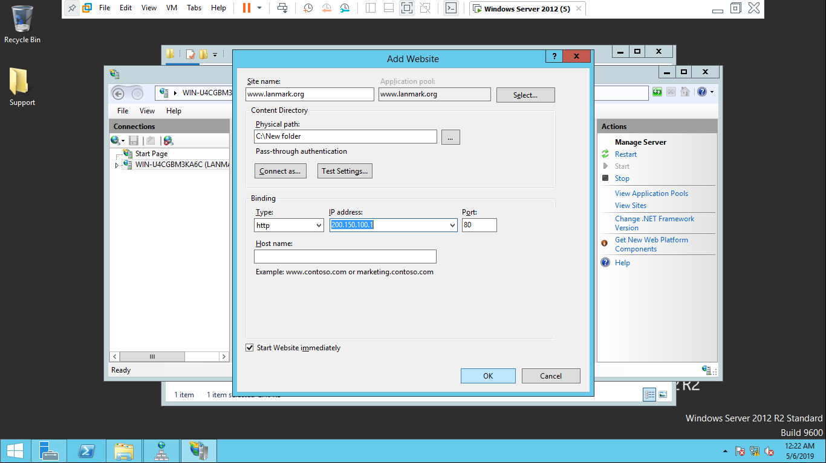

* Open IIS manager >click on default document>clear or delete all default file from it>click on add >enter the file name (lanmark.html) which is created in a folder.



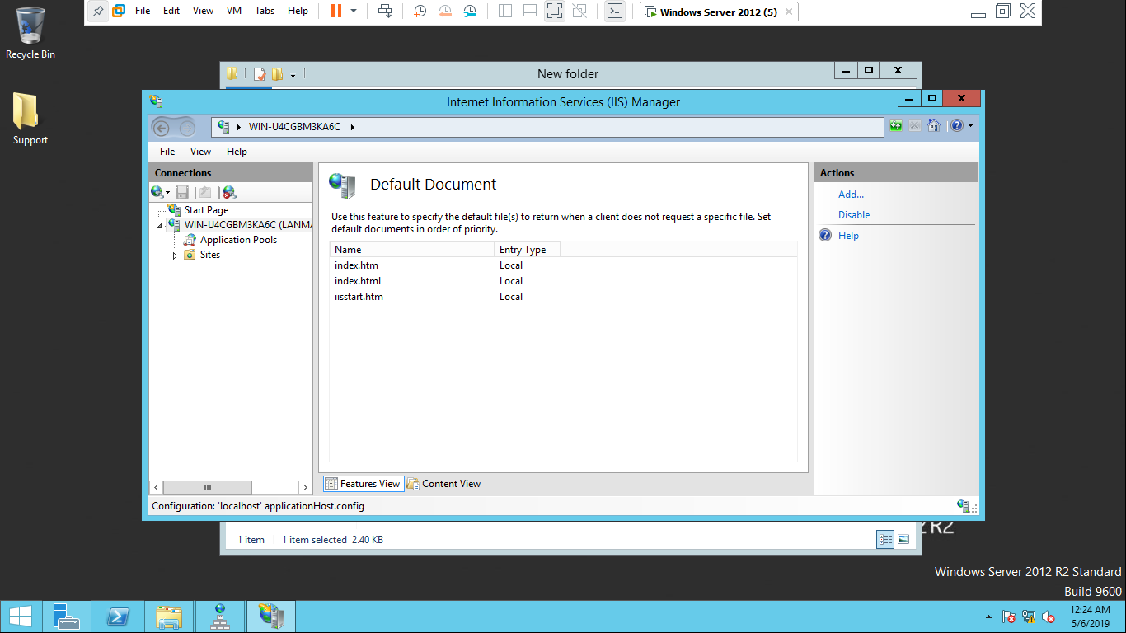

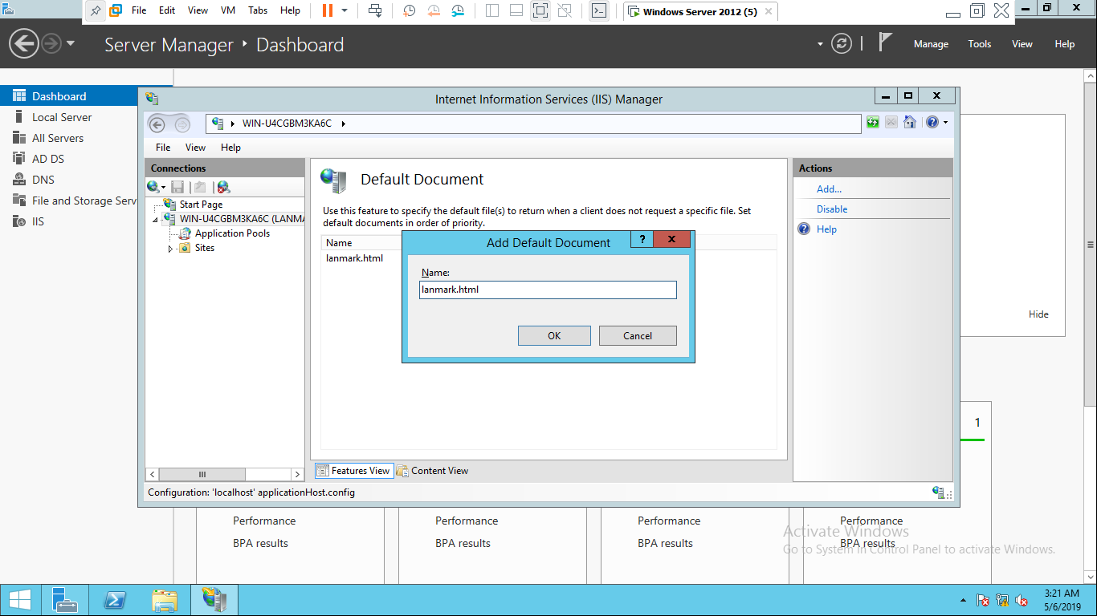

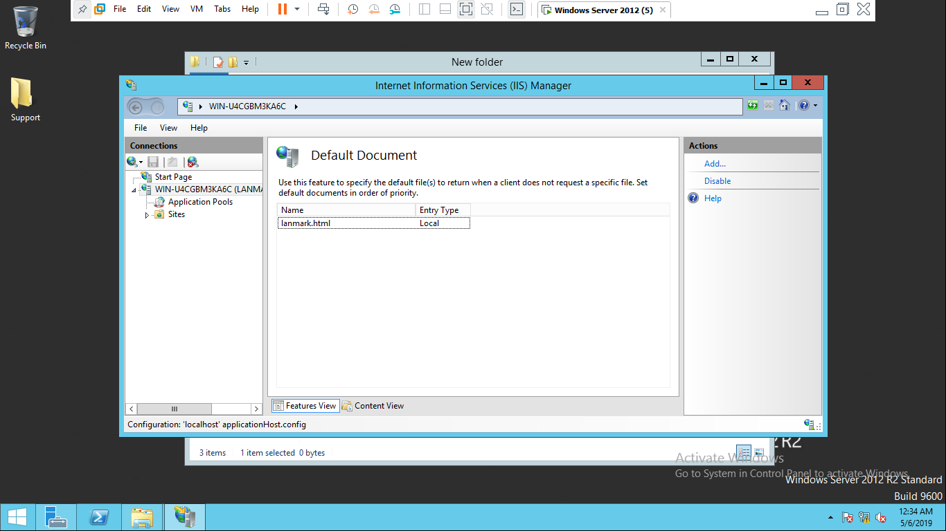

* 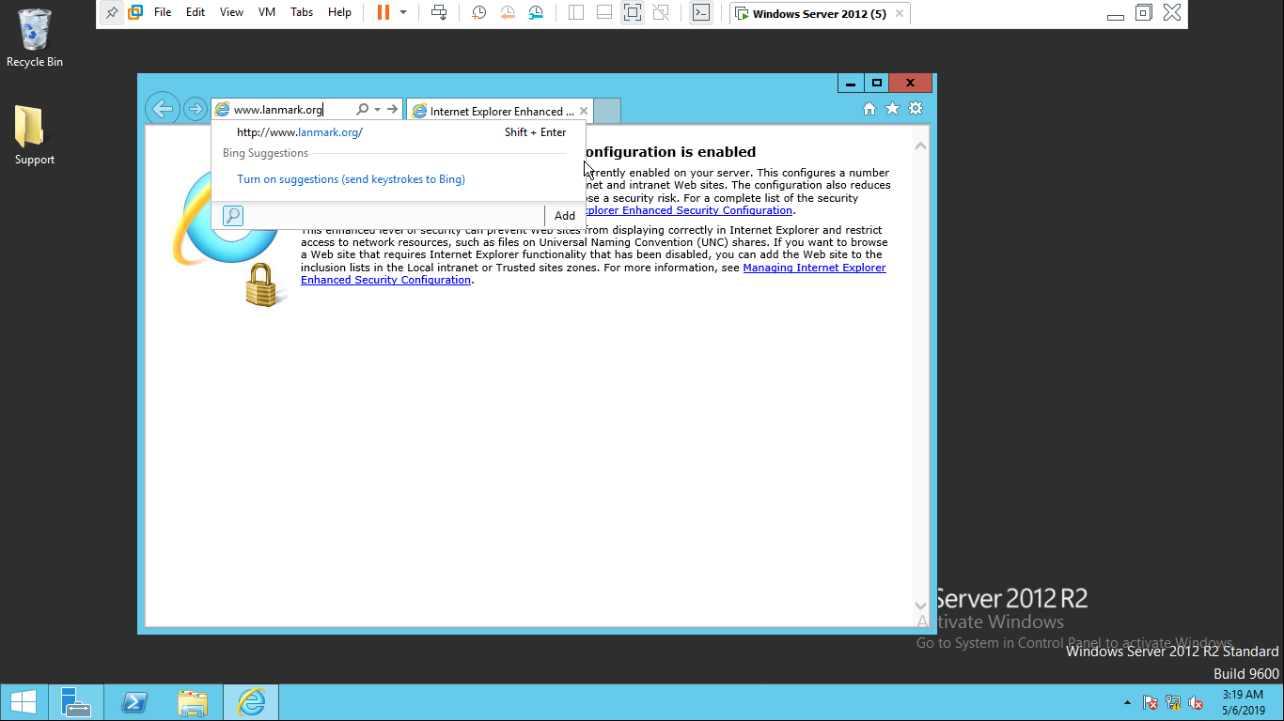OPEN internet explorer >enter the web site which was created(www.lanmark.com)

Lanmark.com.np

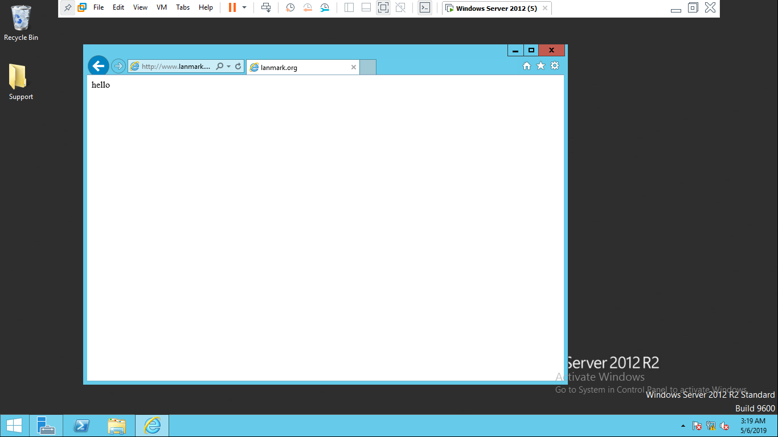

## DHCP installation:

Introduction

A DHCP server is a network server that offers and gives client applications automatically IP addresses, default gateways and other network parameters. It depends on the normal protocol called the Dynamic Host Configuration Protocol or DHCP to react to customers ' relay queries. Without it, each client that enters the network must be set up manually by the network administrator, which can be cumbersome, especially in big networks.

Advantages of DHCP:

1. DHCP servers provide tools for logging and managing to help administrators handle their scope of IP addresses.
2. It can support large number of networks which have large number of data.
3. It helps to get control from any kind of mistakes due to IP address management and It also helps to spread the IP addresses that are attached to the DHCP network to the client's laptop.

Configuration in DHCP

Step 1: Go to server manager then click on add rules and features



Step 2: Click on next>>next>>choose select a server from a server pool>>next.



Step 3:Put tick mark on DHCP>>Click on add feature>>Next



Step 4: Click on next>>next>>put tick mark on restart>>Install



B. Creation of new scope

Step 1: Go to tool and choose DHCP



Step 2: Click on DHCP server name>>right click on IPv4>> choose new scope



Step 3: Add a name as you like and Description then click next



Step 4: Then add a IP address and click next



Step 5: leave it empty and click next



Step 6: Add a lease duration for a client computer then click next



Step 7: Enter the computer name in the server name and add IP address and click next



Step 8: Then choose “Yes I want to activate this scope now” and click next>>finish



C. Observation



This shows the IP address taken by the client’s computer which is provided by the DHCP server.

## RODC Server:

**Introduction**

A read-only domain controller (RODC) is a server that supports read-only partitions from an Active Directory database and reacts to applications for safety checks. RODC designed for use in branches that cannot support their own domain controllers

Step 1: Go to server manager>>notification area

Step 2: Choose the first option



Step 3: Click on change and then put username and password, next

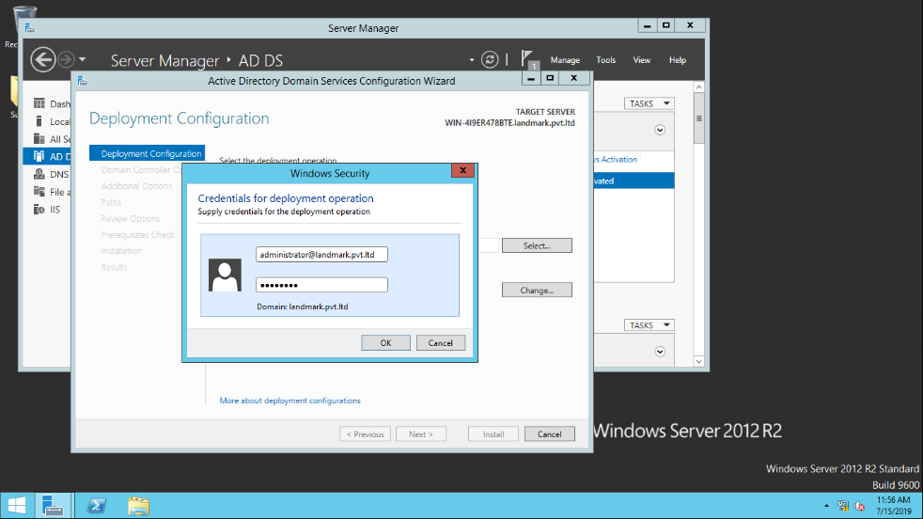

Step 4: Now, put a tick mark in RODC and remove tick marks of DC and GC, type password then next.



Step 5: Click next.



Step 6: Click next

Step 7: Click next twice and then press install.



Step 8: After the completion of installation>> Go to run>>DSA.MSC>>new user.



Step 9: Write new user name.

Step 10: Enter the password for the new user

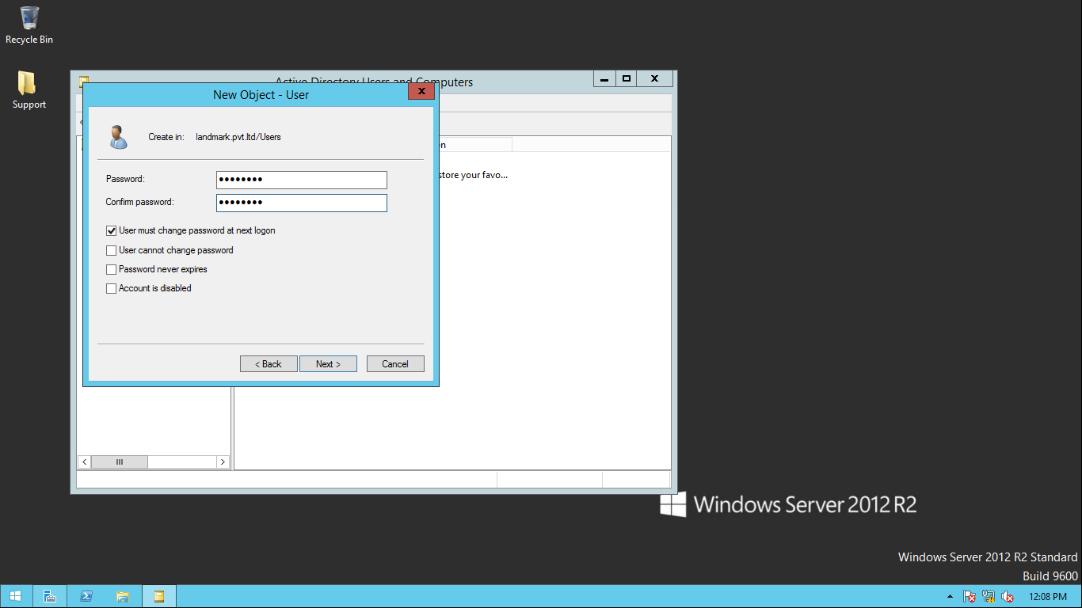

Step 11: Click Finish.

Note: In RODC if we create any user on DC then it will automatically be on the RODC server.

## CDC server:

**Introduction:**

CDC Stands for Child Domain Controller, meaning sub-domain server as well. Basically, CDC is used in a domain controller location in branch headquarters.

We need to install ADDS for CDC and we need to link the same Lan segment between the two computers. We have to set IP in two servers. The steps are same as in DC to install ADDS.

**Installation:**

Step 1: Choose second option then type new domain name i.e. the new child domain name



Step 2: Now put a password and confirm password and next



Step 3: The child domain will show up and then next



Step 4: Select next twice and then press install



Step 5: click finish.

## Print Server

**Introduction:**

Print server is the software that helps to make printer available for every computers or client in the same network. It helps the user to perform a printing job without having to move files to the computer connected directly to the printer.

The prerequisites for printer server are ADDS, DHCP, Print server services**.**

**A. Printer Installation:**

Step 1: Go to server manager>>add roles and feature

Step 2: Next>>Next>> select the print and document services



Step 3: Next



Step 4: Select Print server and click next



Step 5: Then press install



Step 6: Then go to the tools>>and open print management



Step 7: Right click on printer and click Add Printer



Step 8: Select Add a new printer using an existing



Step 9: Now select manufacture and printers>>Next



Step 10: Enable option Share this printer >> Next>> Next



Step 11: Finish. Then install Client OS and create the networks between both server OS and client OS through DHCP**.**



Step 12: Now in client OS go to run>> \\ type an IP address



Step 13: Right click on printer and click connect



**The connecti****on of printer services is done.**

## VPN

Using encryption and other security mechanisms, a VPN secures the private network to ensure that only authorized users can access the network and that data can not be crossed. This type of network is designed to provide a safe, encrypted tunnel for the transmission of information between the distant user and the network of the business.

Installation:

Step 1: Go to server manager>>Add roles and features

Step 2: Select Option Remote Access>>Next>>Next



Step 3: Enable option Direct Access and VPN(RAS)>>Next



Step 4: Then Click Install



Step 5: Now Open Tools>>Remote Access



Step 6: Then Click on Direct Access and VPN>> Run the getting Started Wizard>>click on Deploy VPN only



Step 7: Now Right click on Server name>>Click on configure and Enable Routing Access>>Next.



Step 8: Now select on Remote Access (dial-up or VPN)>>Next



Step 9: Select option VPN>>Next



Step 10: Now add another network card>>Go to VM>>Settings>>add

(Keep its Lan segment 2>>OK.



Step 10: Now go to run>>NCPA.CPL>>Ethernet>>Properties>>IPv4



Step 11: Now open Client OS>>Go to Control panel>> Network and sharing center>>Click on set up a new connection or network.



Step 12: Click a connection on a workplace:



Step 13: Now click on Use my Internet connection (VPN)



Step 14: Provide the IP address that is provided by ISP>>Disable all of the option>>Create



Step 15: Now Go to start>>DSA.MSC>>OK



Step 16: In Dial-in>> In Network Access Permission enable option Allow access>>Apply>>OK



Step 17: Open control panel>>Network and internet>> Network Connection>>Right click on VPN connection and connect.



# Maintenance schedule

2019 jan 21st

|  |  |  |  |
| --- | --- | --- | --- |
| Sn | Task | Activities | Time duration |
| 1 | Backup | Backup the important data of the network(only of client) | 10am-11am |
| 2 | System auditing | Audit the entire system | 11am -12pm |
| 3 | Installation or configuration | Install the printers on head office  Configure proxy server on head office | 12pm – 1pm |
| 4 | Device update | Updating all device | 1pm-1:30pm |
| 5 | Password update | Updating password | 1:30 pm -2 pm |
| 6 | Cable repair | Checking cables and repairing broken cables | 2pm – 3pm |
| 7 | Vulnerability testing | Checking system errors | 3pm- 4pm |
| 8 | software update | Updating all softwares | 4pm -5pm |

# Analyses of expected

## 1. ADDS

|  |  |  |  |  |
| --- | --- | --- | --- | --- |
| SN | DATE | WHAT WAS TESTED | EXPECTED OUTPUT | ACTUAL OUTPUT |
| 1 | 7TH APRL 2018 | ADDS | When we type dsa.msc then user name should be shown | These requirements have been met successfully because name is shown. |

## 2. DHCP

|  |  |  |  |  |
| --- | --- | --- | --- | --- |
| SN | DATE | WHAT WAS TESTED | EXPECTED OUTPUT | ACTUAL OUTPUT |
| 1 | 7TH APRL 2018 | DHCP | Client should take dynamic IP | These requirements have been met successfully because client had take dynamic IP |

## 3. VPN server

|  |  |  |  |  |
| --- | --- | --- | --- | --- |
| SN | DATE | WHAT WAS TESTED | EXPECTED OUTPUT | ACTUAL OUTPUT |
| 1 | 7TH APRL 2018 | VPN server | The VPN connection should be set up by the client computer. | These requirements have been met successfully because the connection has been setup. |

## 4. PRINT server

|  |  |  |  |  |
| --- | --- | --- | --- | --- |
| SN | DATE | WHAT WAS TESTED | EXPECTED OUTPUT | ACTUAL OUTPUT |
| 1 | 7TH APRL 2018 | PRINT server | Every laptop has to share a printer. | These requirements have been met successfully because the every laptop has shared same printer |

## 5. WEB server

|  |  |  |  |  |
| --- | --- | --- | --- | --- |
| SN | DATE | WHAT WAS TESTED | EXPECTED OUTPUT | Remark |
| 1 | 7TH APRL 2018 | WEB server | The web page on the main server should be prepared to show web pages on the client computer. | These requirements have been met successfully because the web page has been shown on the server |

# Recommendation for potential

1. New security mechanism(devices): using high quality devices such as cisco devices, mikro-tech devices
2. Replacing switch by router: Router is intelligence and it has prebuilt security techniques so if we use replace the switch by router for better improvements.
3. Performing auditing and mapping: To checkup the health of network we have to perform
4. Using biometric security: For making system more secured, we have to install biometric security.
5. Avoiding third party software: By using third party software, it will be more risky. Hacker can easily hack using this third party software.
6. Regular maintenance and checkup: every server should be maintained and tested every day so that security level will be maintained properly and due to this system there will be less chance of error.
7. Updating and Testing of the system: every server should be updated and tested time to time xo updating and testing security is needed.
8. Linux server: We need to adopt Linux servers and overlook the windows server to render our environment safer and faster.
9. Backup system: we must have backup system because it will help in getting information if any data is lost due to any disturbance or accident.
10. Security specialist: security specialist is required for updating, maintain of a network.

# Summarization of all the task

* 1. Network design: which server, devices,
  2. Test plan of the design:
  3. Implementation of the design
  4. Configuring the servers and client computer on head office and branch office
  5. Diagnosis of the implementation network(system checking)
  6. Negative & positive aspects of the implemented network
  7. Recommendation for further improvements
  8. Preparing the maintainace schedule.
  9. Evaluation of own work.

# Bibliography

Anon., n.d. [Online]   
Available at: https://searchwindowsserver.techtarget.com/definition/RODC-read-only-domain-controller

Anon., n.d. *geeksforgeeks.* [Online]   
Available at: https://www.geeksforgeeks.org/network-devices-hub-repeater-bridge-switch-router-gateways/

Anon., n.d. *technopedia.* [Online]   
Available at: https://www.techopedia.com/definition/4193/domain-controller-dc

Anon., n.d. *tutorialpoint.* [Online]   
Available at: https://www.tutorialspoint.com/Network-Standardization

Anon., n.d. *webopedia.* [Online]   
Available at: https://www.webopedia.com/TERM/V/VPN.html